Admin User Manual

ePATHUSA Inc.

Admin Login
We have same admin login for both DETR and JobConnect website. You need to select either DETR or JobConnect logo to login into their respective CMS.
- Give the required credentials
- Select the site
- Click Login
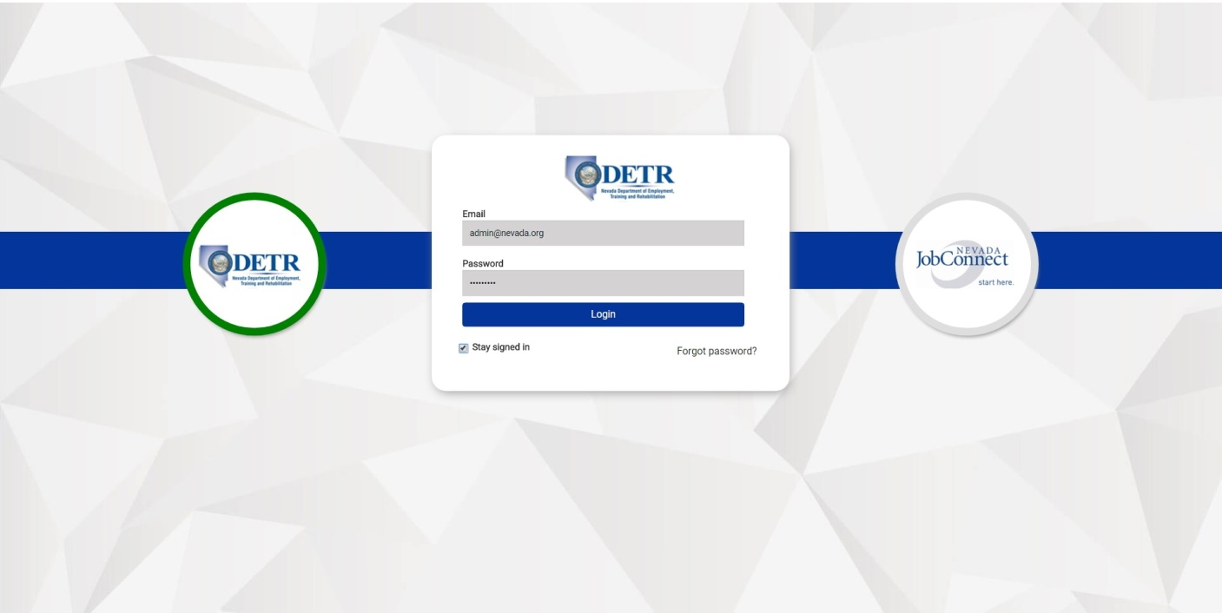

- If the credentials are correct, it will authorize the admin and open the Dashboard (Homepage) with the following menus. Please refer to the image below.

Dashboard  Quick Links  Menu Master  Pages  Media  Users  Settings | 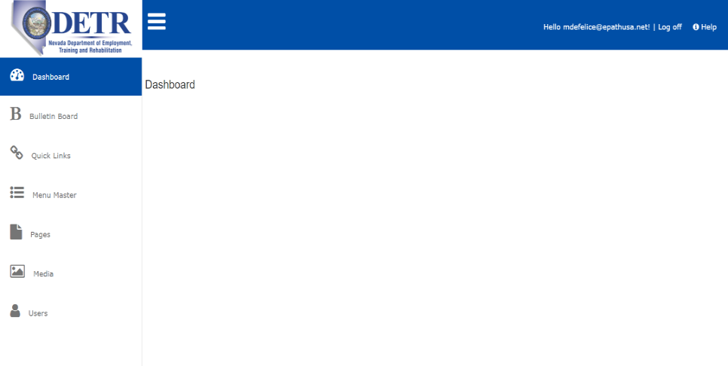
Dashboard  Quick Links  Menu Master  Pages  Media  Users  Settings | 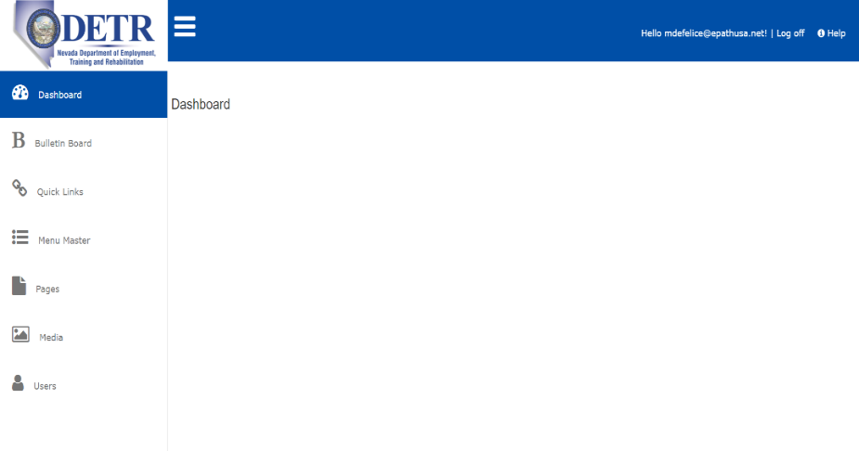

Bulletin Board
The Bulletin Board is a viewable list of news and updates found on the homepage. It can be found on the right-hand sidebar. Please refer image below.

- To add a bulletin, click on the Bulletin Board button from the dashboard.
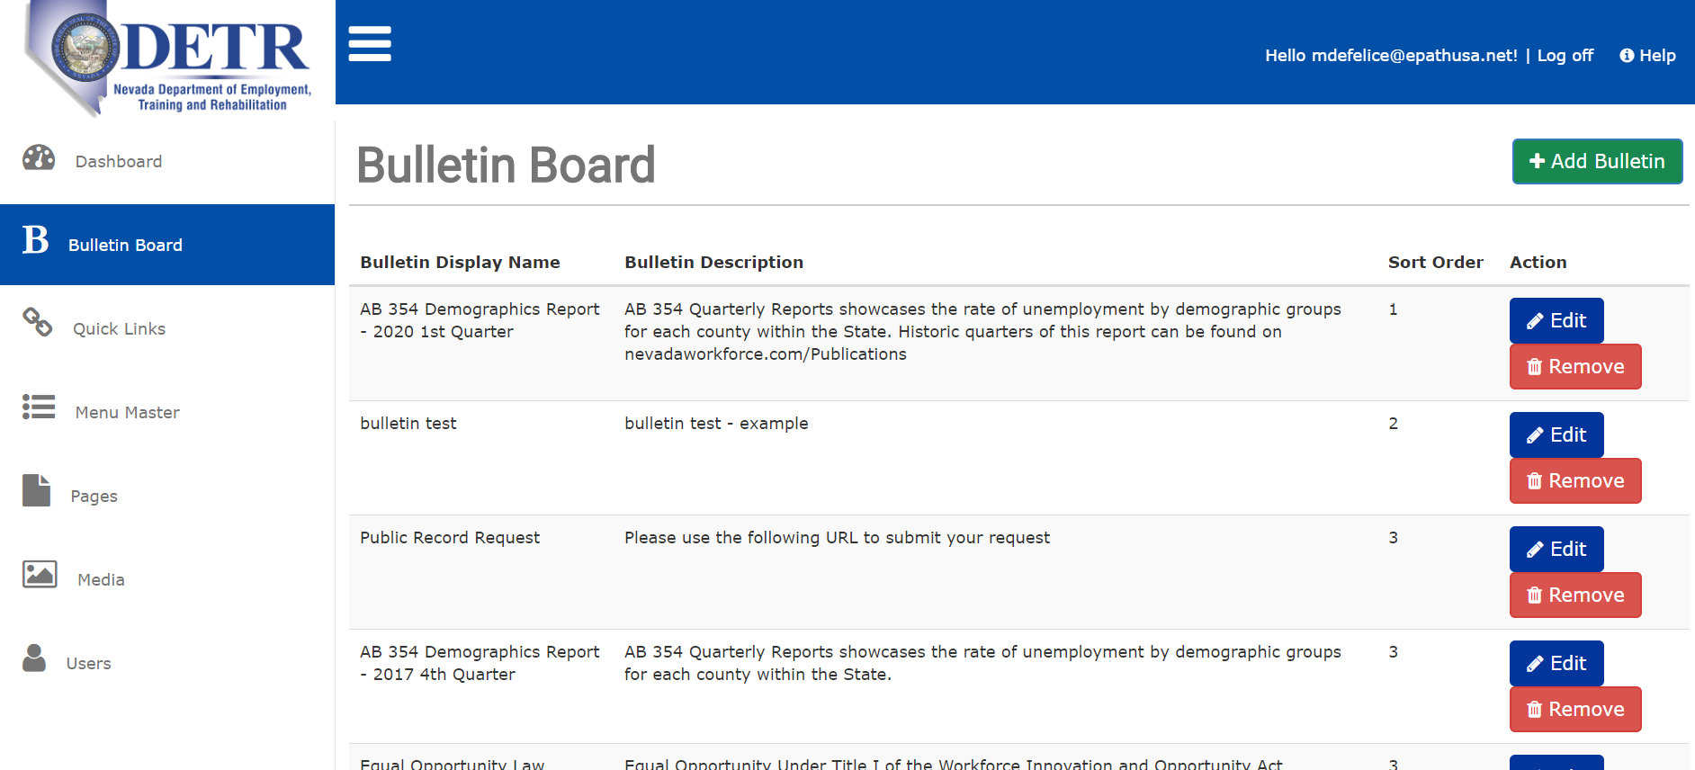
- Click Add Bulletin to create a new bulletin.
- Once the user clicks on the Add Bulletin button, a from field will appear as seen in the image below.
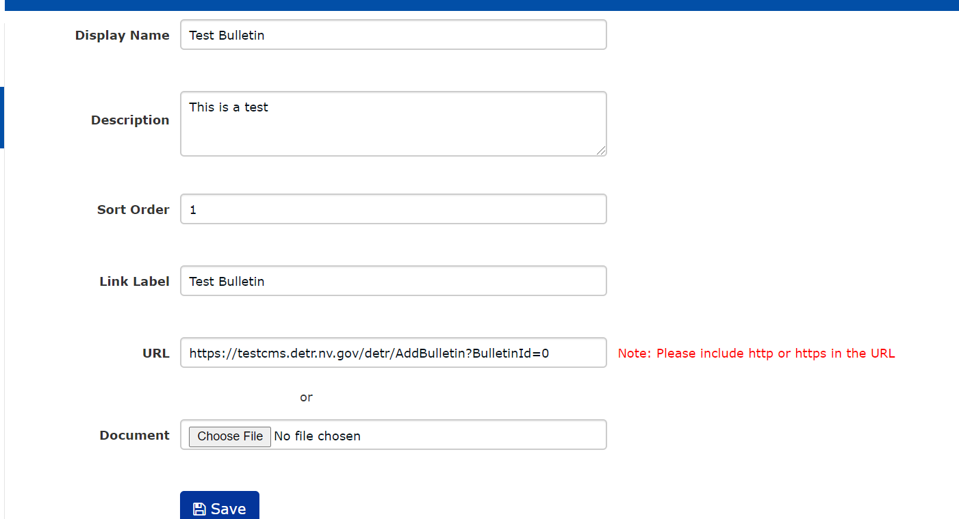
- Enter the Display Name of your bulletin.
- The Display Name will appear on the homepage as seen in the image below.
- Enter the Description of your bulletin.
- Your Description will appear on the homepage as seen in the image below.
- Select the order in which your bulletin will appear on the bulletin board by entering the Sort Order number.
- Enter the name of a chosen landing page link in the Link Label field.
- Your link will appear on the homepage as seen in the image below.
- Enter the URL your chosen landing page or upload a Document
- The bulletin will appear on the right-hand sidebar on the homepage in the order sorted as seen in the image below.
- *Needs Image of New Bulletin

Quick Links
Quick Links is viewable from the sidebar. Please refer image below.

- To open Quick Links, click on the Quick Links button.

- Once the user clicks on the Quick Links button, the user can Add/Update, Edit, or Deactivate the links. Please refer image below.
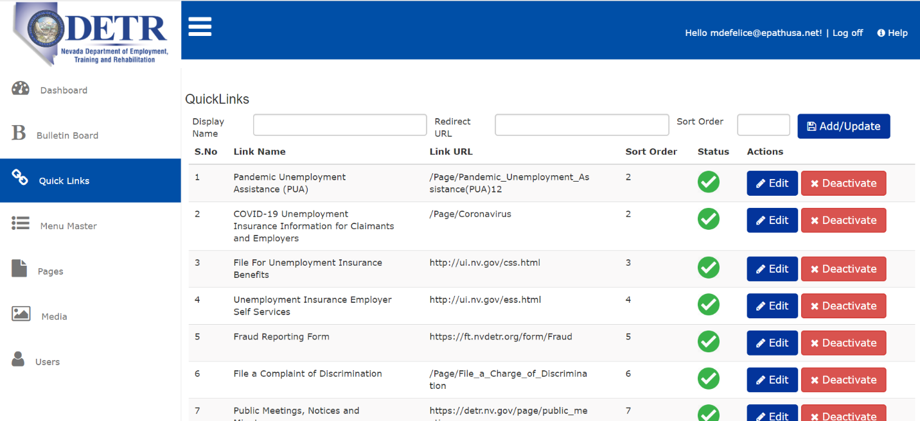

- Add Quick Links - Enter the three (3) required fields and click the Add /Update Button. After clicking Add/Update, the quick links will appear in the list below.

Note: Quick Links display names should be unique entries.

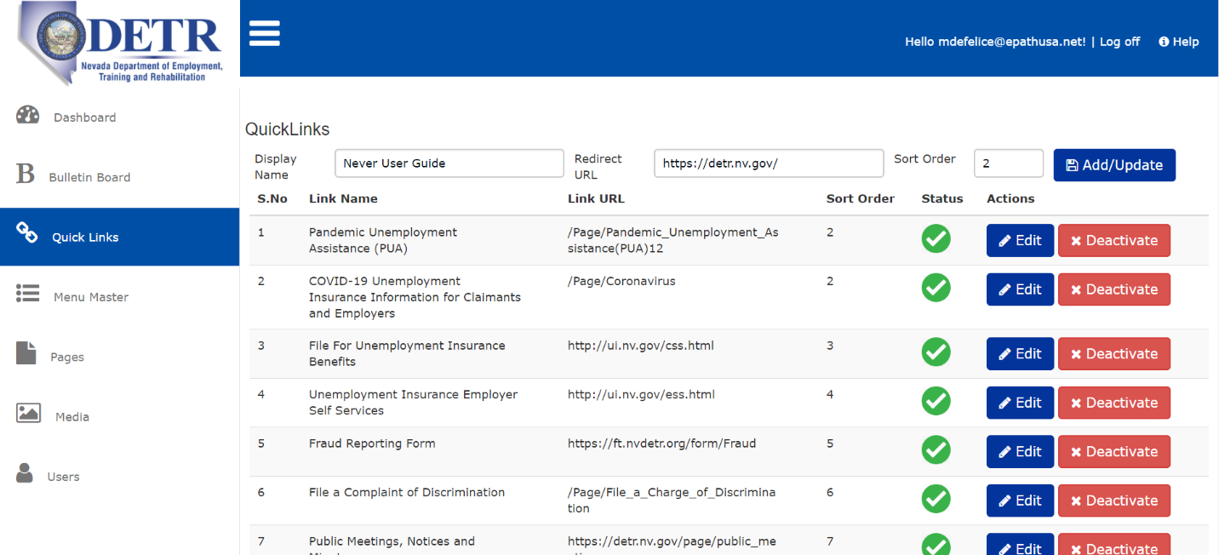

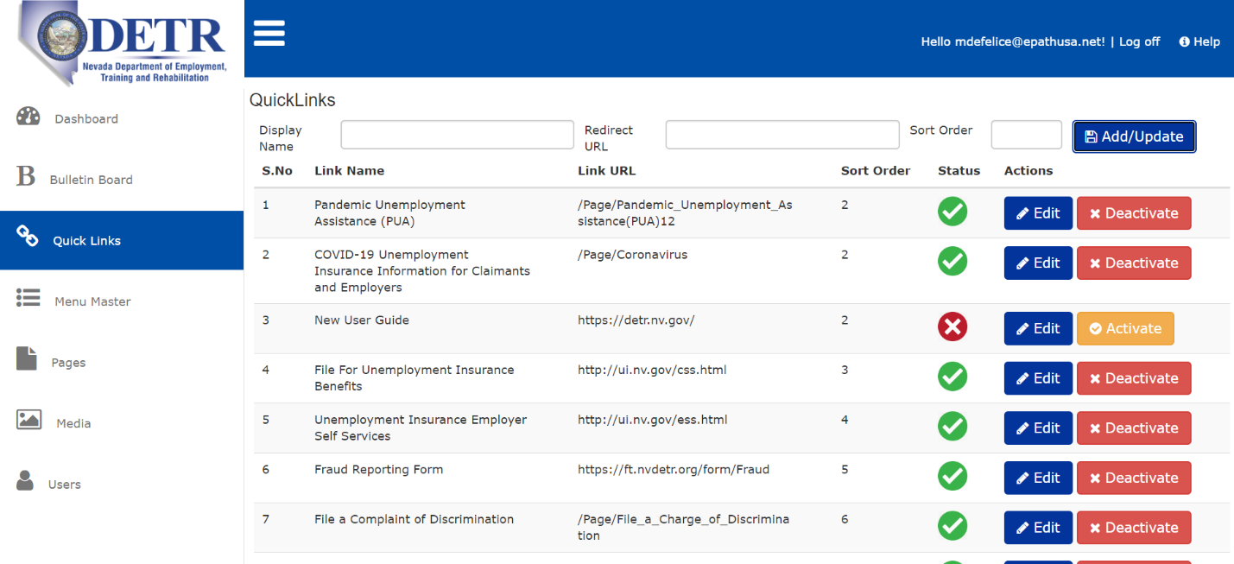
- Edit Quick Links - Click on Edit button in the quick link list. The display name and redirect URL will be populated in the above text boxes.
After editing, click on the Add/update button to save the edited content.

Quick Link Deactivate/ Activate:
- If certain quick links are not required to be displayed on the public site, you can use this option.
- If you click the Deactivate button, a confirmation alert will appear (Are you sure, do you want to activate/deactivate this quick link?).
- Clicking Ok will deactivate that particular quick link.
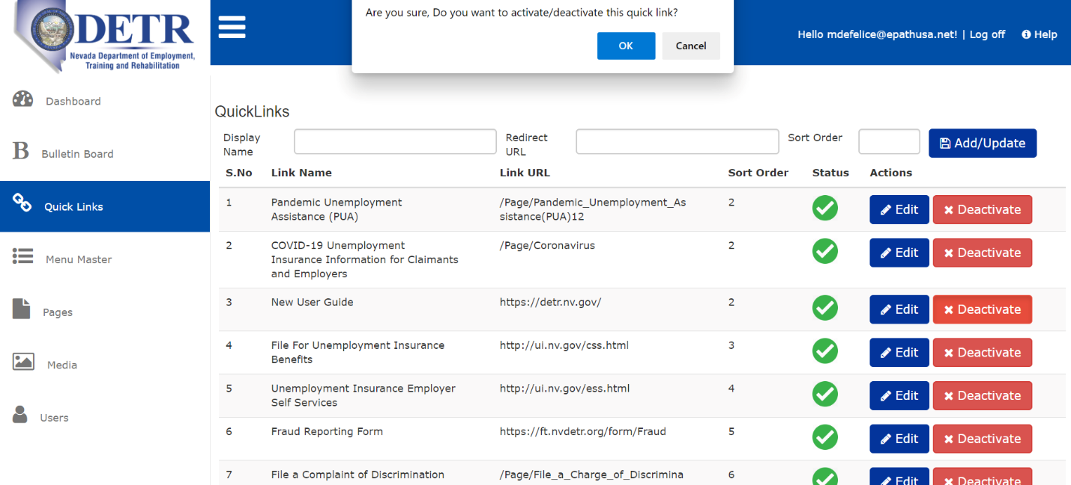

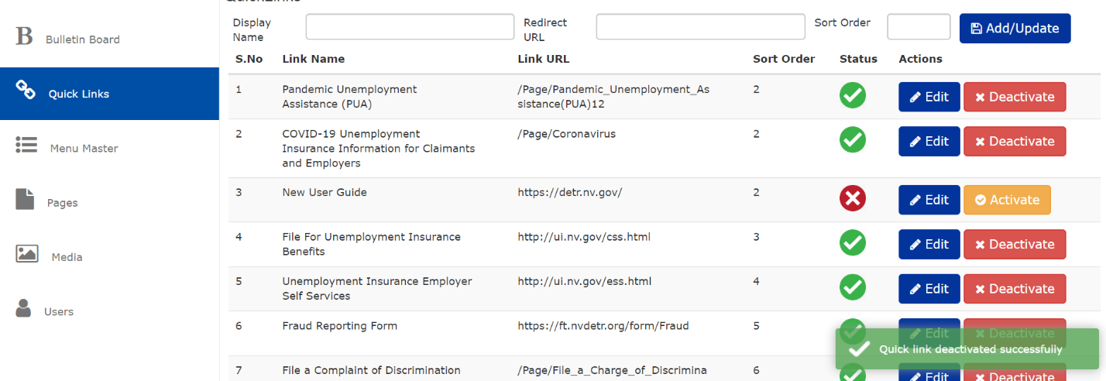
Activate Quick Link:
- click the Activate button next to the deactivated link, once activate button is clicked a message window will pop-up as shown in the image below. Click Ok to Activate.
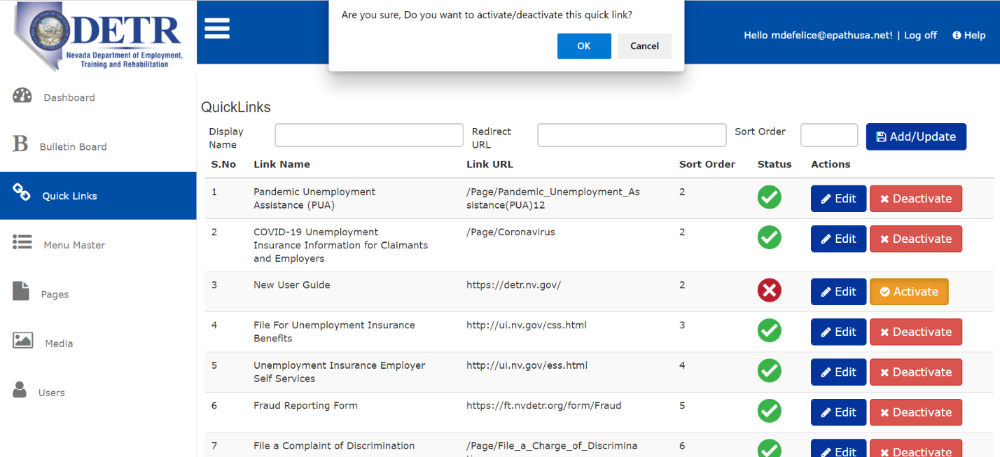

The link will be activated and a message will pop up as confirmation as shown in the image below.
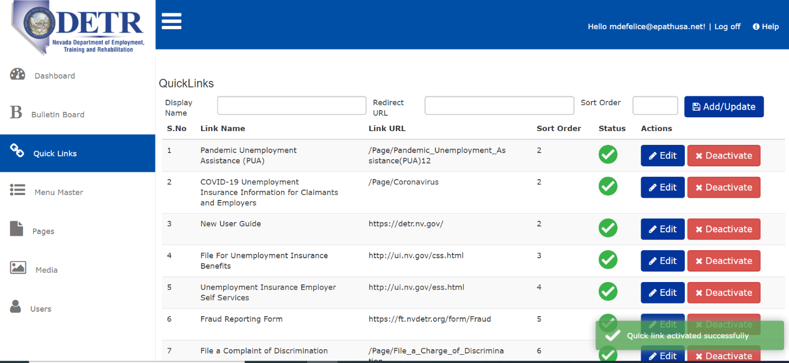

Menu Master:
Here a user can add menu items for the website homepage.
Click on the Menu Master button. The Menu Master page will open as shown in the image.
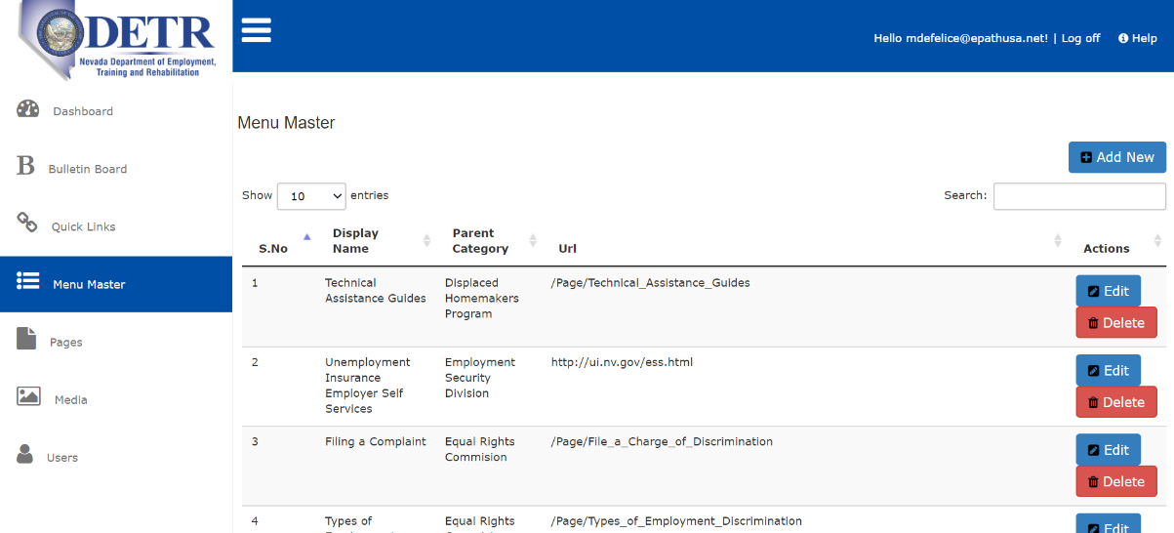 | To minimize the side menu index, click on the icon. Once clicked, the menu index will collapse as seen in the image below.
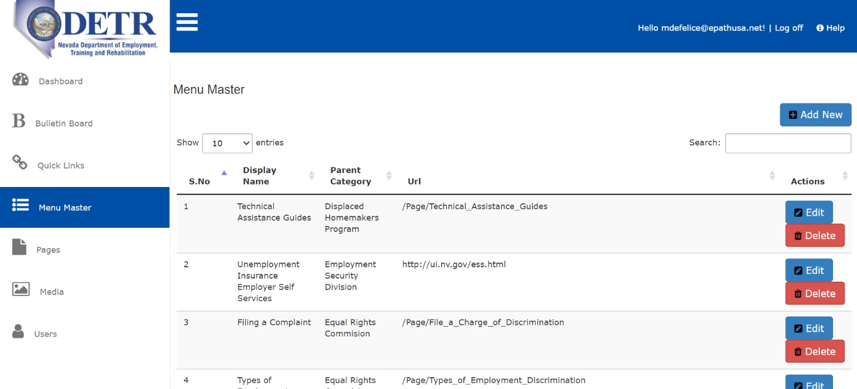

Add New Menu:
- Click on Add New button as shown in above image.
- Once clicked, an Add Menu window will appear as shown in the image below.
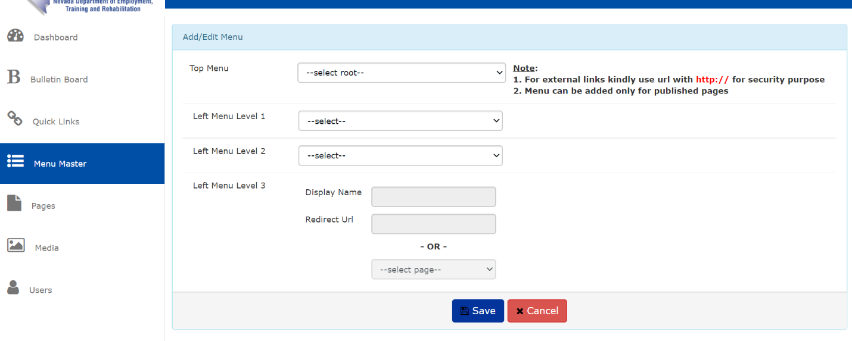
- The Add Menu window contains the following options as shown in the image below.
- Top Menu see elaboration and use below
- Left Menu Level 1
- Left Menu Level 2
- Level Menu Level 3
For elaboration and use of these menus, please refer to the below image.
- In menu master all fields are mandatory

The Top Menu represents the top four menus of the public website as shown in the image below.

Left Menu Level 1 is the sub menu of a Top Menu. When any Top Menu is clicked in the website, these sub menus open, which we refer to as Left Menus in CMS. Please refer to the image below.

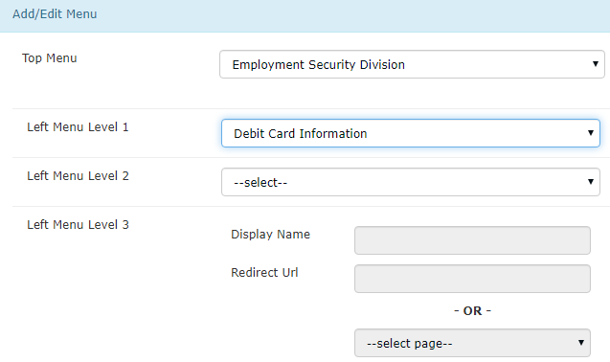 | - Before selecting or adding a Level 1 Menu, the user needs to select the Top Menu.  - Here we selected Employment Security Division as the Top Menu.  - And we added Debit Card Information as the Level 1 Menu.  - Please refer to the image on left for CMS and the image on top for the website.

Left Menu Level 2 drop down is the sub menu under the Left Menu Level 1. The menu items with the icon to their right contain Level 2 Menus. Please refer to the image below.

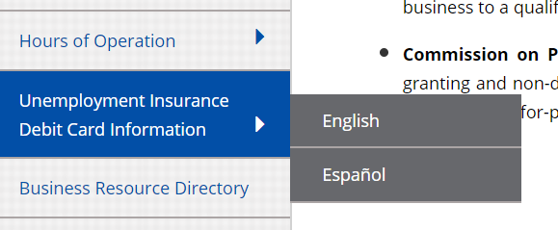
To add new Level 2 Menu in CMS, click on the Left Menu Level 2 and select Add New from the drop down as shown in the image below.
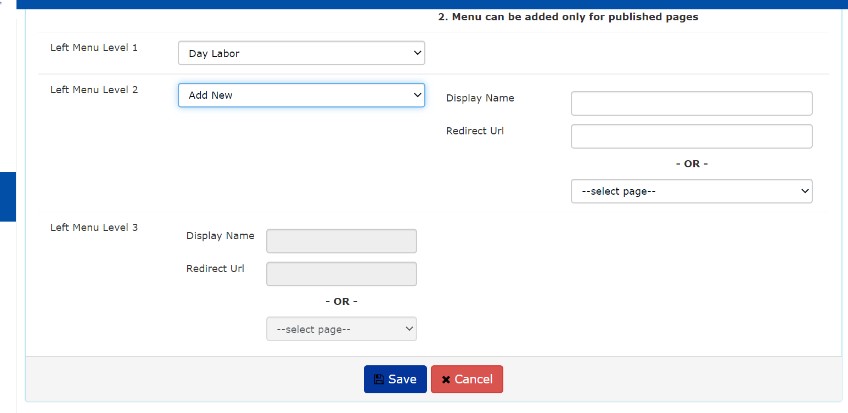

- After selecting the Top Menu, left menu level 1 will be enabled, in that drop down either you can add new menu or else you can select some level 1 menu and add level 2 menus for that.
- All fields are required to add new menu, either you can give the external link as a redirect URL or else you can select some page from the select page dropdown.
- Click save to store the menu.
- Please refer image in top for adding the Level 2 Left Menu under Level 1 in CMS and how it will look in the website is also show in the top most image of this title.
Left Menu Level 3 is the landing page for any menu.

- Select the Level 1 Menu for which you want to add the Level 2 Menu. Fill out all the required fields and save. The same needs to be done for Level 3 Menu.
Note: You can’t add sub menus for external links menu items. Because sub menus can be added only to the internal pages, when you select the external link i.e. Redirect URL while creating Level 2 Menu that will be the landing page for the Level 1 Menu. Likewise, when you are selecting a Redirect URL (i.e. external link) in a Level 3 Menu, it will become the landing page for Level 2 Menu.
Pages
- In page menu admin can Add new page, edit pages, delete pages and view list of the existing pages.
Add New Page
- Click on Add Page button it redirects to the add page window as shown in the image below.
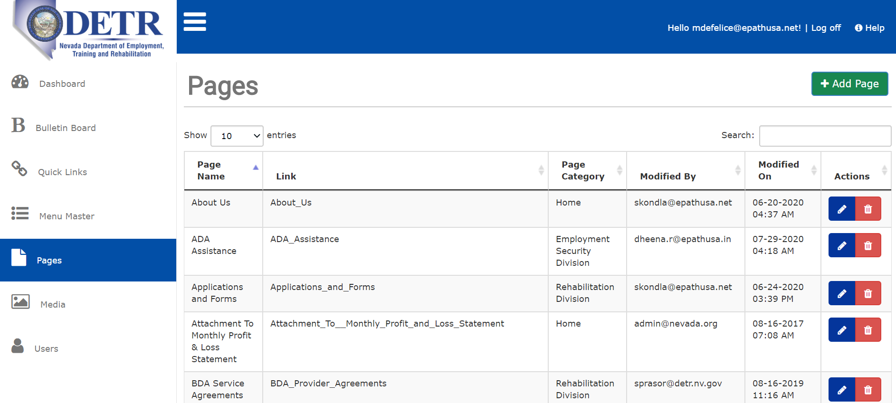
- In Add/Edit page window following fields are required Page Name, Page Category, Meta Keyword and page content.
- Enter the values in the fields. Fields with “*” sign are mandatory. Please refer image below for mandatory fields.
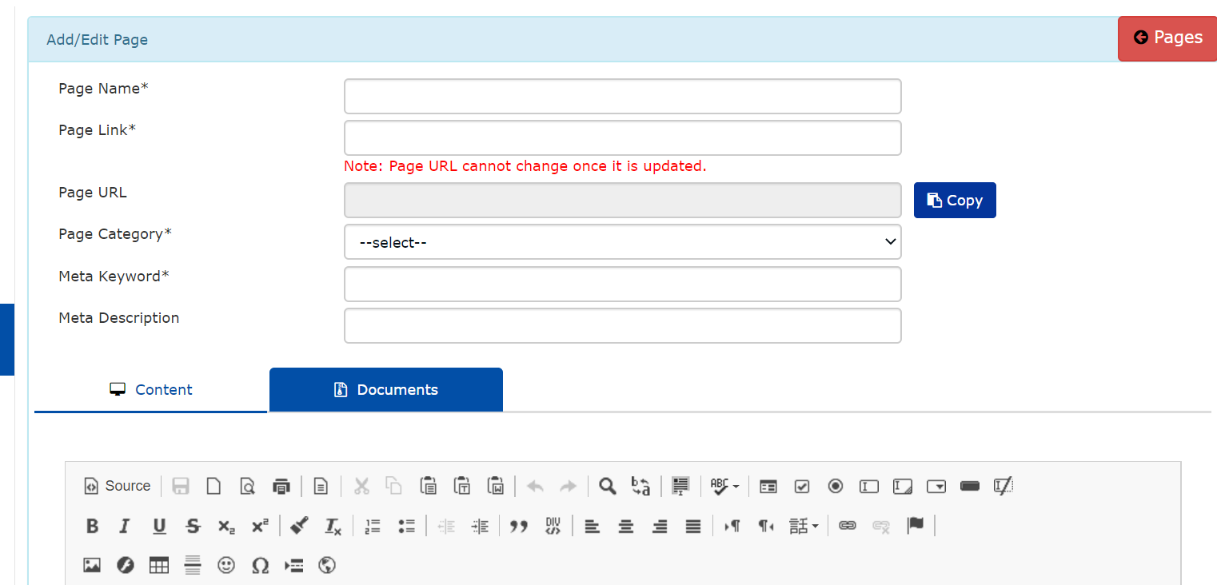

- Page Name*: It is a mandatory field, please enter a page name you would like to add to the website.
- Page Category: To put the page under a category, you should select Page Category from the drop-down button as shown in the image below. This is not a mandatory field, but it is required if a user want to preview the page during editing.
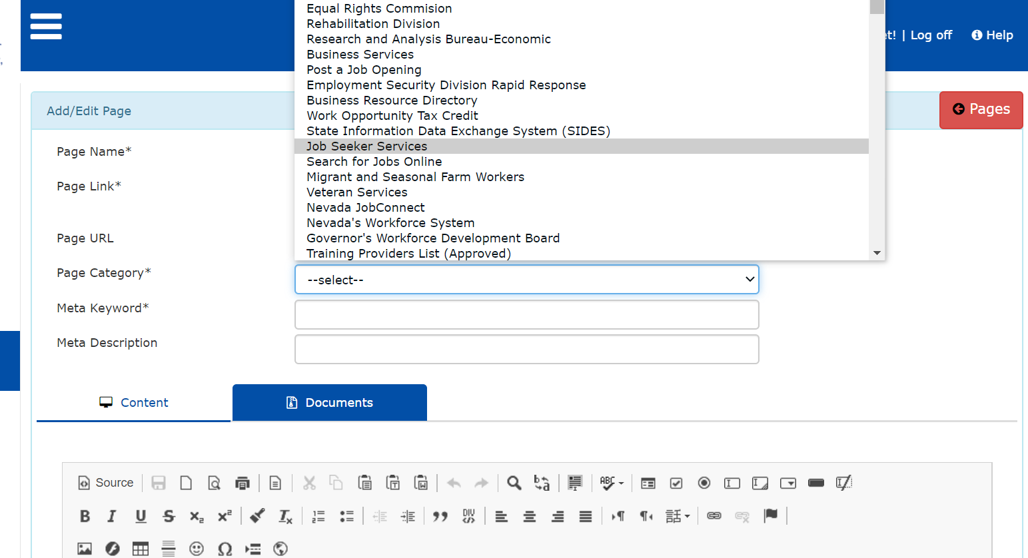

- Meta Keyword*: This field is the mandatory field. To create a page, you must give the Meta keyword for the new page. It is required to help tell search engines what the topic of the page is.
- The most important thing to keep in mind when selecting or optimizing your Meta Keywords is to be sure that each keyword accurately reflects the content of your pages.
- As a rule, don’t use more than about 10 Meta Keywords for a single page. Please refer to the image below for reference.

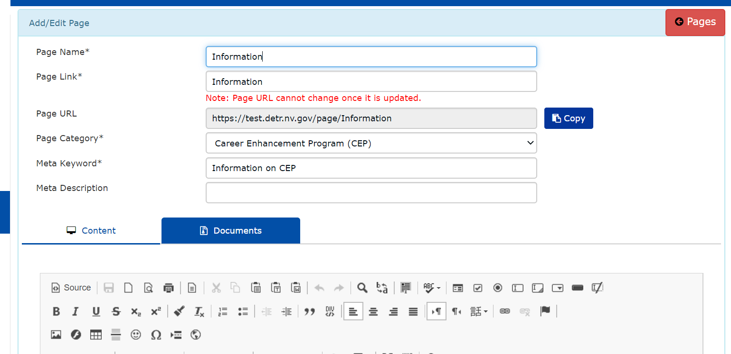
- Meta Description: Meta descriptions play an important role in search rankings. Writing an engaging meta description is important because the primary function of a meta description is to explain what is on a webpage prior to entering the site.
The character limit for Meta description is approximately 150 – 170 characters. They appear like the image below on most search engines (we took this one from Google for reference):
This is how your standard meta description will be seen on Google.
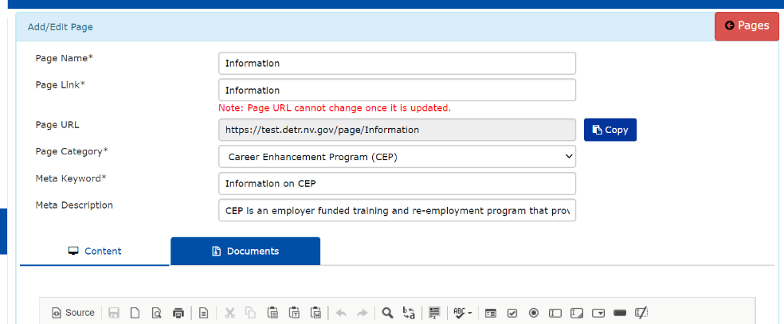
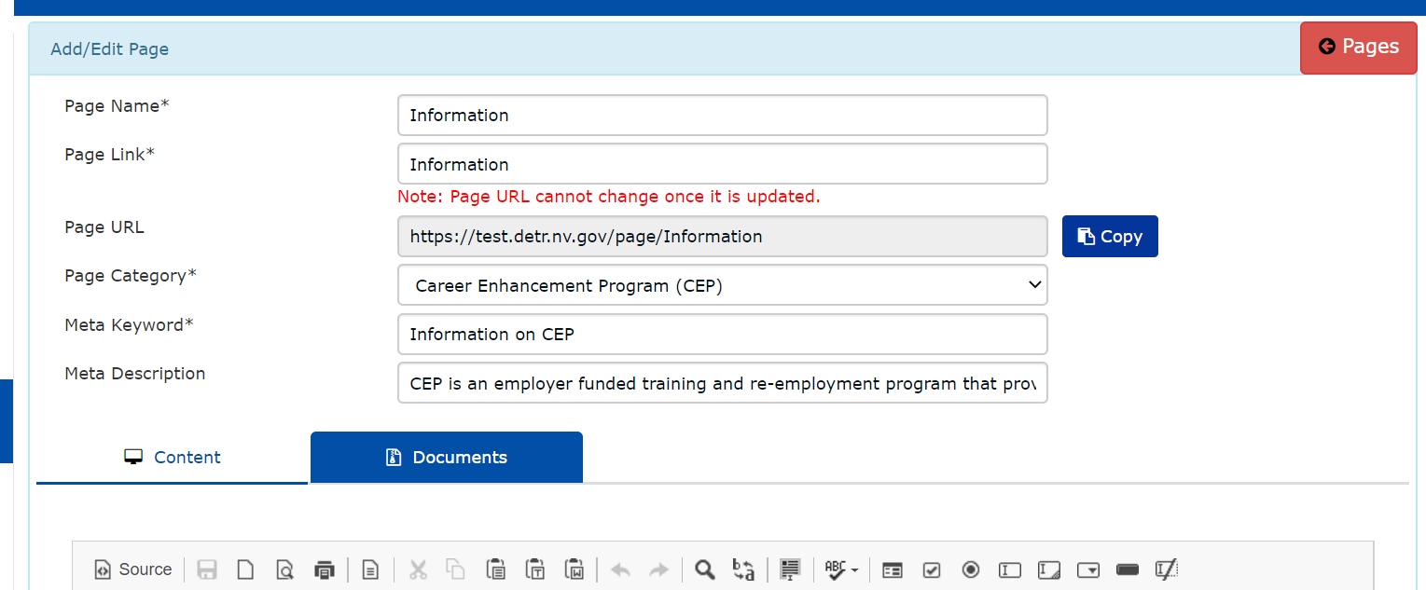
- After entering all the required fields as shown in the image above, the user can start adding the content to the page. Please refer to the Content Tab below to learn how to add content to the page.

Content Tab:
This tab is used to add the content to a page. You can either select the preset template for adding content to the new page or you can add text, images, link buttons, and forms while customizing the way you would like your new page to be visible on the website.
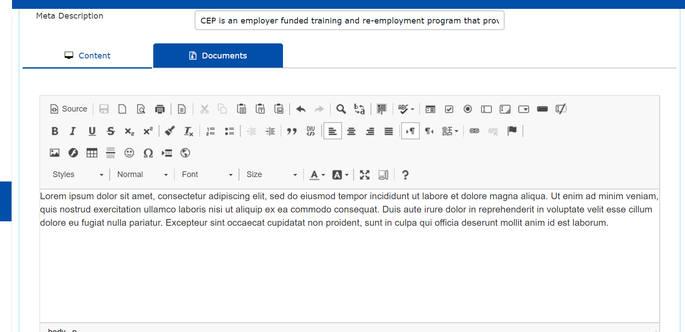

Note: CKEditor is the platform for all the icons in the content page. Refer to the CKEditor icon manual by clicking on the Icon in the editor box for the manual on icons in the editor.
https://ckeditor.com/docs/ckeditor4/latest/examples/index.html

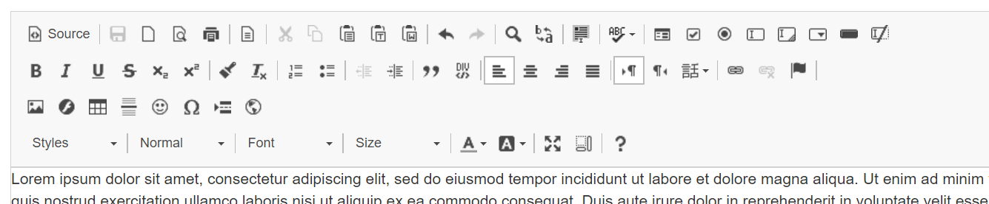

For the user’s convenience, the use of each icon in the editor related to data formatting is elaborated on in the table below.

Table listing out feature’s and use of each icon in the Editor.
Icon | Name | Description
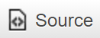 | Source | Repository of HTML source code. For details please refer page 22
 | Save | It is used to save page editing at any time.
 | New page | It is used to clear content and start a new page.
 | Preview | It is used to see how the page will be visible on a website.
 | Print | It is used to print the “preview of the page.” Once this button is clicked, it will automatically print the preview.
 | Templates | It is used to choose any pre-build template for your new page. When this icon is clicked, a window will pop up with the options shown in the image. Select an option and start filling the content as per the design. |  | 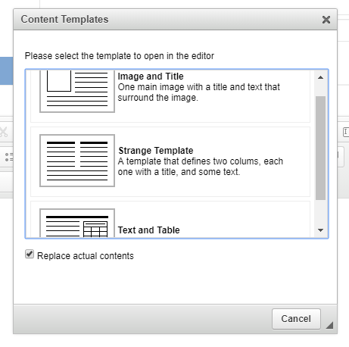
 | Cut | It is used to delete content. Select the content you want to delete and click on this icon to cut it. Content will be deleted.
 | Copy | It is used to copy any content.
 | Paste | It is used to paste the content you have copied in a clipboard. | 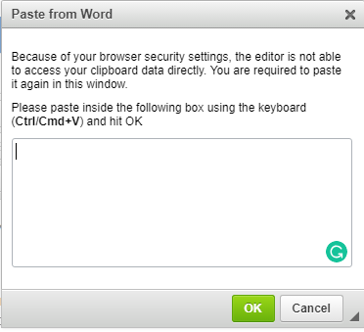  For security you user is required to paste the content using this window.
 | Paste as plain text | It is used when a user wants to paste any content without original formatting. It will be pasted as plain text.
 | Paste from word | It is used to paste the content directly from word document.
 | Undo & Redo | It is used to redo or undo your last action.
 | Find | It is used to search the word in the page. When clicked, a window will pop up with below options.
 |  | 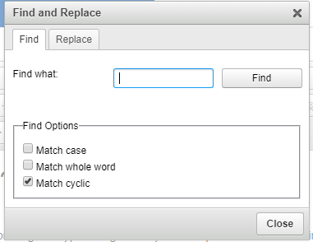 | Type the word in “Find what.”  Choose an option to get more specific results for the search.
 | Replace | It is used to replace a text/value with new value/text.
 | Select All | It is used to select all the content of the page editor at once.
 | Spell Checker | Click on this icon to check spelling mistakes. When there is a mistake, it will get highlighted.
The icons below marked in RED can be used only in forms, these are Form Element only.
 | Form | Please refer page 22-23 for details on use of Form icon.
 | Checkbox | Please refer page 23-24 for details on use of Checkbox Icon.
 | Radio Button | Please refer page 24 for details on use of Radio Icon.
 | Text Field | Please refer page 25 for details on use of Text field.
 | Text Area | Please refer page 26 for details on use of Text Area in a page.
 | Selection Field | Please refer page 27-28 for details on adding Selection field in a page.
 | Button | Please refer page 28-29 for details on adding a Button in a page.
 | Image Button | Please refer page 29 for details on adding Image button in a page.
 | Hidden Field | Please refer page 30 for details on adding Hidden field in a page.
 | Font Style | It is used to style the text either in Bold, Italics, Underline
 | Strike through Font Style | It is used to strike through the text. Ex. “TEXT”
 | Subscript | It is used when you have any subscript. Ex. “COS₂”
 | Superscript | It is used when you have any Superscript. Ex. “5th”
 | Remove format | It is used to remove any kind of formatting or style in the content.
 | Listing | It is used for listing any text into bullets or numbers. | - Item A |  | - Item A
 |  |  | - Item B |  | - Item B
 | Increase and Decrease Indent | Use this to increase or decrease the distance between the paragraph/content or the beginning of the paragraph/content.
 | Block Quote | The BLOCKQUOTE tag designates quoted text - generally long quotations where a paragraph break is appropriate. Highlight a word and press the I button to get wrapped in "em" tags.
 | Create Div. Container | It is used to create a div container to create divisions, or to group block-elements for styling. When clicked it opens in new window. 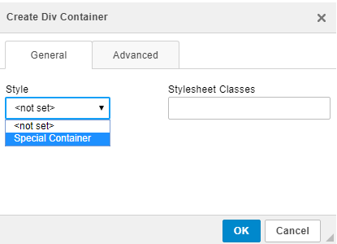  - In the general tab, you can add Style and/or Stylesheet Classes.  - In the advanced tab, you can apply more customization by adding the ID and other details like the language code, style, and advisory title.
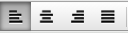 | Text Alignment | Use these buttons for alignment you can either Left Align, Center Align, Right Align, or Justify the content of the page.
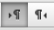 | Text Direction | It is used to Change the direction of the text to the left side of the page or side of the page.
 | Set Language | Choose a different language for the page content, by default the language will be English.
 | Link | Please refer page 31 for details on how to insert a link in a page using this Icon.
 | Anchor | Please refer page 31-32 for details on how to anchor a text or image in a page using this icon.
 | Image | Please refer page 32-34 for details on how to insert image in a page using this icon.
 | Flash | Please refer page 34-36 for details on how to insert Flash in a page using this icon.
 | Table | It is used to insert table in the page. To learn more please refer Page 37.
 | Horizontal Line | It is used to insert a Horizontal line in the page. A horizontal line can be used to add sections in the page
 | Smiley | It is used to add the emotion icons to the page. Click on the button and choose an option to be inserted in the page.
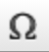 | Insert a symbol | It is used to insert special character or symbols in the page content.
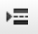 | Page break | It is used to add the page break in the page for printing. Move the cursor where a page break needs to be added and click on the icon.
 | Iframe | Please refer page 38 for details on how to insert Iframe in a page using this icon.
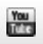 | YouTube | It is used to insert the YouTube link in to web page. Take the cursor where you want to add the YouTube link, click on the icon a window will pop-up fill the required fields and press ok. A YouTube link will be added. A preview tab at the bottom will let you view how it looks in the webs page.
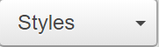 | Formatting styles | It is used to choose the style of the text. Select the text in the editor, click on the button, and choose the style from the drop down.
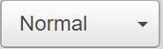 | Paragraph format | It is used to change the format of text that affects an entire paragraph or is different from other paragraphs in a document. Select the paragraph and click on the icon. Choose the formatting option from the drop down.
 | Font Name | To change a font for a text fragment, open the Font menu by clicking the icon button on the toolbar. The font drop-down list contains several typefaces that you can use. To make the choice easier, the font names are displayed in the font that they represent, giving you a preview of what the text will look like.
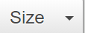 | Font Size | It is used to change the font size for selected text in the page.
 | Text Color | It is used to add color to text/content. Ex: Sample If you want to quickly remove colors from your document, use the icon
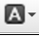 | Background color | To add background to the text. Ex: Sample
 | Maximize | It is used to maximize the editor inside a browser window. After the click the editor will look like desktop word processor user. To minimize the window, click again on the icon.
 | Show blocks | Is used to visualize all block-level elements by surrounding them with an outline and displaying their element name at the top-left. With click on the icon user will be able to differentiate all the pieces/blocks in the page editor.
 | CKE editor info | It is the manual for the editor in use. Click on this icon to see the user manual for editor.

Source Icon
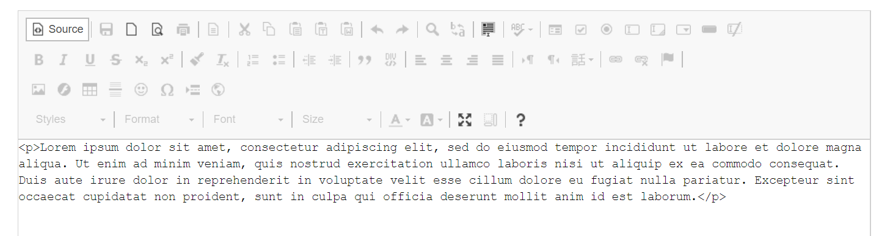
This page contains HTML source code. If you are a more advanced user, you can use the source text in the editor. This allows you to use HTML to format your text. Source code automatically updates when a user creates/edits the page using the content editor.

Note: Creating a page using source code requires technical knowledge. It is suggested that if a user is not aware of the technical process to work in the HTML source code that they should not make any changes to the source code of any page.

Before you begin working in the source code, please know that Technical Support will not provide any assistance with this section.

Form Icon and Form Elements. All the icons below are elaborated on below.

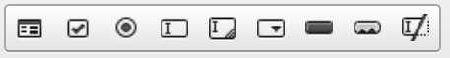

The form element is a setting for all form contents, which means that all form controls (e.g. checkboxes, text fields, or buttons) must be placed inside it. To insert the form into your document, click the Form icon. The Form Properties dialog window will open and let you configure basic form settings that control the form's interaction with the server.
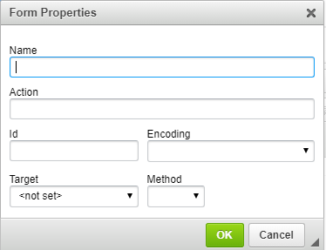 | - Name – the name of the form (name attribute).  - Action – the location of the application that processes the form data (action attribute).  - Id – the unique identifier for a form element in the document (id attribute).  - Encoding – the parameter that specifies how the form data should be encoded before sending to the server (enctype attribute).  - Target – the window where the results will be displayed after you send the form to the server (target attribute). You can choose between New Window (_blank), Topmost Window (_top), Same Window (_self), or Parent Window (_parent).  - Method – the way the data should be sent to the server (method attribute). You can choose between GET and POST.

Check Box Icon :
A checkbox is a form element that lets you select an item and send your selection to the server. Multiple checkboxes may be combined in a logical group, although their selection is independent of one another, which means that more than one item of the group can be selected at a time.
To insert a checkbox into a document in Editor, place the cursor inside the form element and press the Check Box Icon. The Checkbox Properties dialog window that will open lets you set the name and value of a checkbox as well as decide whether it should be selected by default.

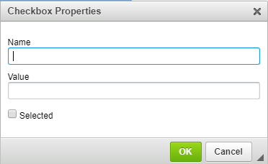 | Below is an overview of all Checkbox Properties dialog window elements  - Name – the name of the checkbox element (name attribute).  - Value – the value of the checkbox element (value attribute).  Add multiple options in value using coma. Like Sojourner truth, Fredrick Douglass, Booker T.Washington, George Washington Carver.  - Selected – the parameter that specifies the default state of the checkbox — whether it is selected or not (checked attribute).

Once you configure the checkbox and click the OK button, the checkbox will be visible in Editor editing area and you will be able to add some text that describes the checkbox option.
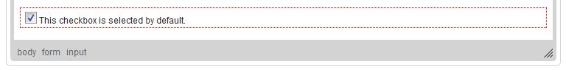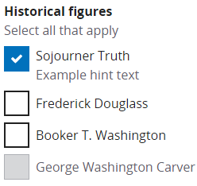
Radio Button Icon

A radio button is a form element that lets you select one item from a list of items. Your selection will be sent to the server when you are submitting the form. Radio buttons are usually used in groups, and they differ from another form element, the checkbox, in that only one (1) item can be selected at a time.
To insert a radio button into a document in the Editor, place the cursor inside the form element and press the Radio icon. The Radio Button Properties dialog window that will open lets you set the name and value of a radio button as well as decide whether it should be selected by default.
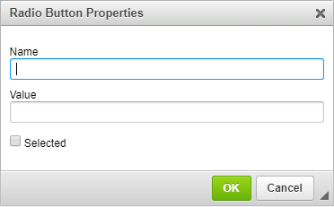 | Below is an overview of all Radio Button Properties dialog window elements:  - Name – the name of the radio button element (name attribute).  - Value – the value of the radio button element (value attribute). E.g. entering “Yes” or “No” in the value.  - Selected – the parameter that specifies the default state of the radio button—whether it is selected or not (checked attribute).

Once you configure the radio button and click the OK button, the radio button will be visible in Editor editing area and you will be able to add some text that describes the radio button option.

Text Field Icon
A text field is a form element that lets you enter text into a single-line field and send your input to the server when you are submitting the form. Text fields differ from another form element, the text area, in that they are single-line fields and thus are meant for shorter entries.
A text field element comes in two variants. The first one lets you enter the text and see it as you type. The second one is used for entering passwords and obscures the typed characters with an asterisk (*), a bullet (•), or another symbol used by the browser.
To insert a text field into a document in Editor, place the cursor inside the form element and press the icon. The Text Field Properties dialog window that will open lets you set the name, value, type, and size of a text field.

Below is an overview of all Text Field Properties dialog window elements:
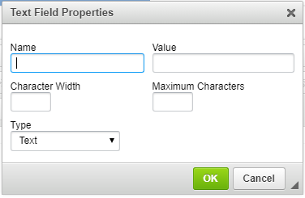 | - Name – the name of the text field element (name attribute).  - Value – the value of the text field element (value attribute). This text will be visible in the text field when the form is loaded in the browser. You can add any value here, such as age and state.  - Character Width – the width of the text field specified as the number of characters that will fit in the field (size attribute). If omitted, the text field will have a default size determined by the browser.  - Maximum Characters – the limit of characters that may be entered in the text field (maxlength attribute). If omitted, the length of text that you enter the field will be unlimited and once you exceed the size of the box, the text will scroll to the right.  - Type – the parameter that specifies whether the form field will be used for plain text (type="text" attribute) or passwords (type="password” attribute).
Once you configure the text field and click the OK button, the text field will be visible in Editor editing area with the default value shown either as plain text or a series of asterisks/bullets.
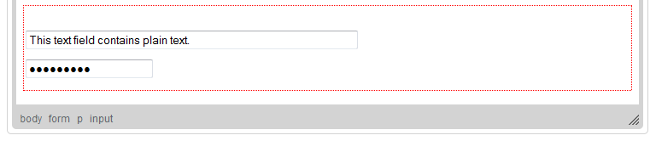
The figure above shows two text fields added to a form. The first one is a text type with character width set to 60 and the second one is a password type with a default character width set by the browser.
Text Area Icon
A text area is a form element that lets you enter text into a multiline, scrollable field, and send your input to the server when you are submitting the form. Text areas differ from another form element, the text field, in that they are multiline fields and thus are meant for longer entries.
To insert a text area into a document in Editor, place the cursor inside the form element and press the icon. The Text area Properties dialog window that will open lets you set the name and size of a text area.
Below is an overview of all Text area Properties dialog window elements:
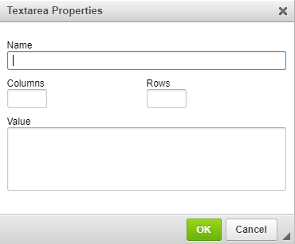 | - Name – the name of the text area element (name attribute).  - Columns – the width of the text area specified as the number of characters in the line (cols attribute). If omitted, the text area will have a default width determined by the browser.  - Rows – the number of lines of text that will be displayed in the text area (rows attribute). If omitted, the text area will have a default height determined by the browser.
Once you configure the text area and click the OK button, the text area will be visible in the Editor editing area as an empty rectangle.
The figure above shows a text area added to a form. Since the text area element does not accept a default message that would be shown in the field, it is presented as an empty rectangle. Depending on a browser, a vertical scrollbar might also be visible, and it might be possible to resize the text area by clicking its frame and dragging with a mouse.
Resizable text area element with a scrollbar added to a form in Editor shown in Internet Explorer
Selection Field Icon

A selection field is a form element that lets you select one or more items from the scrollable list and sends your selection to the server once submitted. Selection fields usually contain numerous options and depending on the settings, you can either limit the selection to one item or choose multiple items by holding the Ctrl key while selecting them with a mouse or an Arrow key on your keyboard.

To insert a selection field into a document in Editor, place the cursor inside the form element and press the icon. The Selection Field Properties dialog window that will open lets you set the name of a selection field as well as the number and content of available options

Below is an overview of all Selection Field Properties dialog window elements:
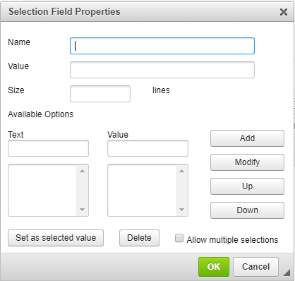  Once you configure the selection field and click the OK button, the selection field will be visible in Editor editing area. | Name – the name of the selection field element (name attribute).  Value – the value of the selection field element (value attribute). This option is filled in automatically when you set one of the items as a selected value. Give a value with and click add button. Ex.  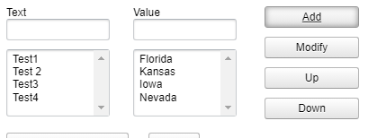  Size – the number of rows of the selection field that are visible by default (size attribute). If the selection field contains more items, a scrollbar will appear.  Available Options – this section contains the options that the user will be able to choose from the selection field.  - Text – the label of the selection field option.  - Value – the value of the selection field option submitted to the server.  - Add – adds an option to the selection field.  - Modify – modifies a selected option.  - Up – moves an option one row up the selection field.  - Down – moves an option one row down the selection field.  - Set as selected value – sets an option as selected by default.  - Delete – deletes a selected option.  - Allow multiple selections – lets the user select more than one option from the selection field.
The figure above shows three buttons added to a form. The first form is a Button type with arbitrary text. The second form is a Submit type, which submits the form to the server, and the third one is a Reset type, which resets the form input fields to their initial values.

Button

A button is a form element that gives the user a visual cue for completing a form action.
Form button element comes in three variants. The first one is a standard button with arbitrary text. The second one is a submit button that submits the form data to the server. The third one is a reset button that resets the form elements to their default values.

To insert a button into a document in Editor, place the cursor inside the form element and press the icon. The Button Properties dialog window will open let the user set the name, value, and type of the button element.

Below is an overview of all Button Properties dialog window elements:

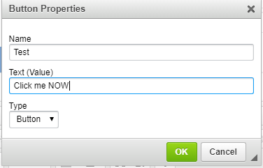 | - Name – the name of the button element (name attribute).  - Text (Value) – the text displayed on the button (value attribute). Any text as shown in left image.  - Type – the button type. Possible options are Button (standard button with arbitrary text; type="button" attribute), Submit (a button that submits the form data to the server; type="submit" attribute), and Reset (a button resetting the form fields to their default values; type="reset" attribute.

Once you configure the button element and click OK, the button will be visible in the Editor editing area with the text specified in the Text (Value) field.

The figure above shows three buttons added to a form. The first one is a Button type with an arbitrary text, the second one is a Submit type submitting the form to the server, and the third one is a Reset type resetting the form input fields to their initial values.

Image Button Icon
An image button is a form element that gives the user a visual cue for completing a form action. It is a clickable image that functions just like a standard button but has a customized appearance.
To insert an image button into a document in Editor, place the cursor inside the form element and press the icon. The Image Button Properties dialog window that will open lets you configure the URL and display options of the custom image button.

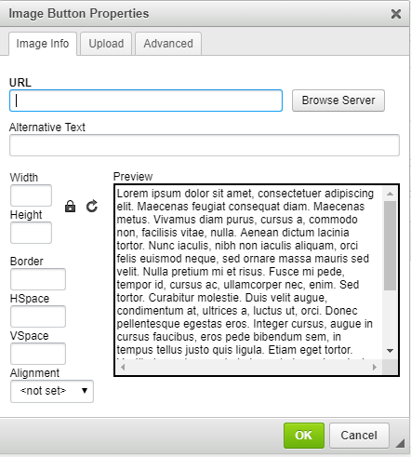 | The Image Button Properties dialog window includes three tabs that group image button options: Image Info, Upload, and Advanced.  Since the configuration options for an image button match the settings for normal images inserted into documents, please refer to the Inserting Images section of the User's Guide.  Once you configure the image button element and click OK, the image button will be visible in the Editor editing area.

Image button added in the page in editor.
Hidden Field Icon
A hidden field is a special form element in that it does not allow any interaction with the user and is hidden from view. At the same time its value is sent to the server when the form is being submitted.

To insert a hidden field into a document in Editor, place the cursor inside the form element and press the icon. The Hidden Field Properties dialog window that will open lets you set the name and value of a hidden field.

Below is an overview of all Hidden Field Properties dialog window elements:

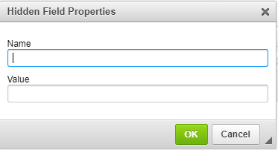 | - Name – the name of the hidden field element (name attribute).  - Value – the value of the hidden field element (value attribute).

Once you configure the hidden field and click the OK button, the hidden field will be visible in Editor editing area as a small icon. Note that as the name suggests, it will be hidden while in preview mode.

A Hidden field is added in the page in editor.
Link Icon

It is used for attaching a link. Once clicked, a window will pop up. Follow steps and image below.
Tab 1-Enter the URL you want to attach to the page
Tab 2- Click the target tab to set how the link will display and where to target the link.
Tab 3-Go to Upload tab to insert and upload any video into the page.
Tab 4-In Advanced tab you can define the name, ID, language direction, Access key, Language code other things as shown in the pictures as per the requirement.
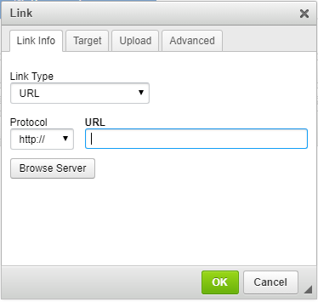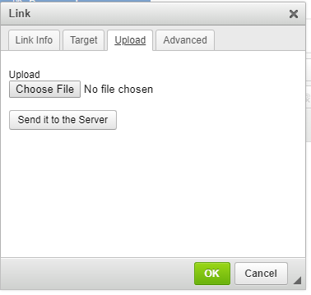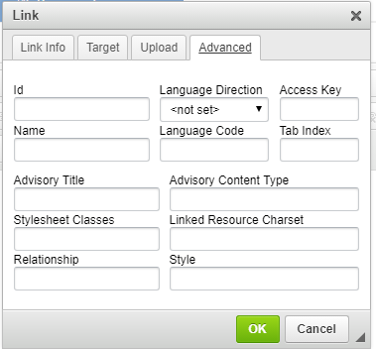
Tab 1 Tab 2 Tab 3 Tab 4

Anchor Icon :
The anchor element is used to create hyperlinks between a source anchor and a destination anchor. The source is the text, image, or button that links to another resource and the destination is the resource that the source anchor links to.
How to use the Anchor Icon:
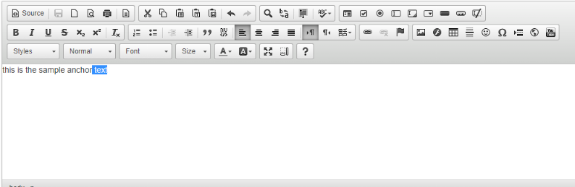
- Position your cursor where you want the anchor placed. Typically, this is the main content point in your page, like a sub-heading.
- Click the "Insert/edit anchor" icon in the editor.
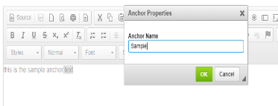
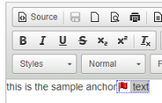
- Enter a short Anchor Id (name) that describes the target anchor. This Id will be used in your link, so it should be lower case and as short and clear as possible.
- Click Ok.
- In the editor, you will now see the "anchor" icon where you placed your anchor. You can also see this by going into the Source Code viewer - an anchor tag looks like: <a id="anchor name"></a>
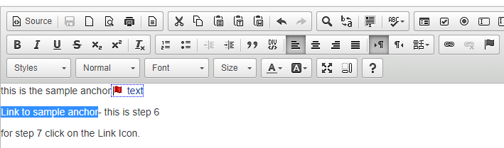
- Now you need to create a link to that anchor. Highlight the word that one would click to get to the anchor (e.g. the "F" in an A-Z index list)
- Click the "Insert Link" icon
- In the Insert/Edit Link box that appears. Leave the Link field blank (don't link to another page).
- In the "Anchor" field, type in the anchor id exactly as you named it (in step 3 above).
- Click "Ok"
- Click "Preview Draft", and then submit your changes on that page.

Image Icon
To insert an image using the 'Insert Image' window:
- In the page editor, place your cursor at the point where you want to insert the image.
- Click the 'Insert Image' icon in the toolbar. The 'Insert/edit image' window will open. See screenshot below with the Image Tab fields and information.
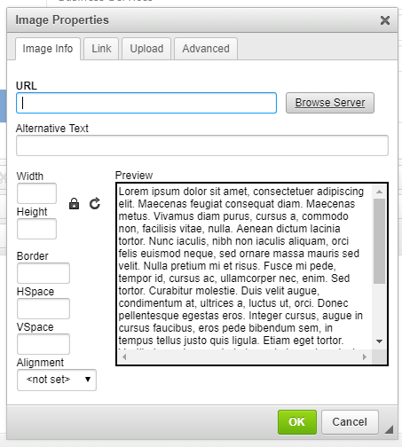 | URL – the web address of the image.  - Alternative Text – a short textual description of the image that tells users with assistive devices (like screen readers) what the image is about. You should always provide your images with meaningful alternative text in order to make it accessible to users with disabilities.  - Width – the width of the image in pixels. By default, this is the size of the original image.  - Height – the height of the image in pixels. By default, this is the size of the original image.  - Border – the size of the solid border around the image in pixels.  - HSpace – the horizontal spacing (or margin) between the image border (if present) or the image itself and other document elements that surround the image, in pixels.  - VSpace – the vertical spacing (or margin) between the image border (if present) or the image itself and other document elements that surround the image in pixels.  - Align – the alignment of the image in the document. Available options are Right and Left.  - Preview – a preliminary view of the selected image formatted according to the options chosen on the left.

- Enter the 'Image Description' for the link. This will provide an additional description about the image that is necessary for accessibility.
- Click the ‘Link’ tab to open a cascade file chooser (see screenshot). Click Browse Server button and select the image you want to insert set the target as per requirement.
- Click the 'Upload' button in the right-hand panel to upload an image from the computer. See the following screenshot:
Go to Advanced tab to add more details to the image preview in the page. | 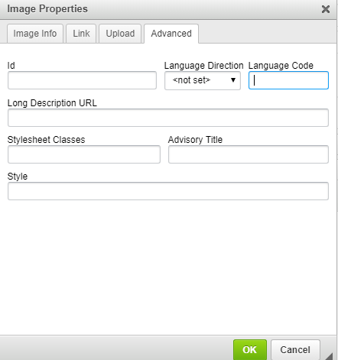
- Go to Advanced tab to add more details to the image preview in the page.

- Id – a unique identifier for an image element in the document (id attribute).
- Language Direction – the direction of the text: left to right (LTR) or right to left (RTL) (dir attribute).
- Language Code – the language of the image element specified according to RFC 1766 (lang attribute).
- Long Description URL – the web address of an HTML page containing a longer description of the image (longdesc attribute).
- Stylesheet Classes – the class of the image element (class attribute). Note that an image element might be assigned more than one class. If this is a case, separate class names with spaces.
- Advisory Title – the text of the tooltip that is shown when the mouse cursor hovers over the image (title attribute).
- Style – CSS style definitions (style attribute). Note that each value must end with a semi-colon and individual properties should be separated with spaces.

Flash Icon : It is used to add animation on the web page. Most commonly used to display the photos in a slideshow.

How to insert the flash file.
- Take the cursor where you want to insert a flash, click on the Flash Icon. A window will pop up as shown in the image below.

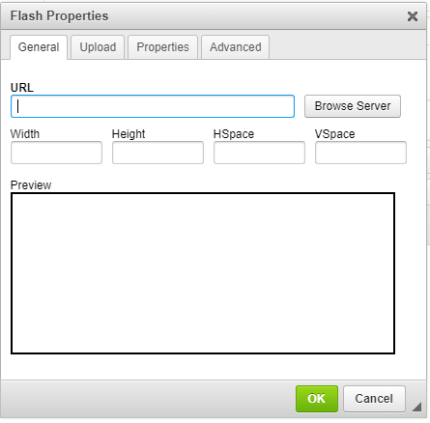 | For General Tab  URL: It is for social menu setup. Enter the URL or browse server.  Width: Choose a width of the flash window  Height: Choose a height of the flash window  Space: It is horizontal spacing  Space: It is vertical spacing  Preview: Here a preview to your above selection is available.

- To upload an image, go to the Upload button and choose file.

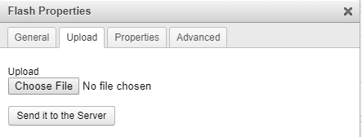

- To set the Properties of the flash go to the Properties tab.

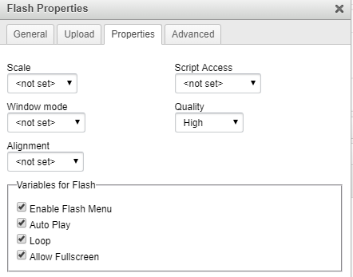 | The Properties tab lets you configure four additional options pertaining to the Flash Player:  - Enable Flash Menu – the parameter that controls whether the Flash context menu is enabled.  - Auto Play – the parameter that controls whether the Flash object will start playing automatically right after you open the document.  - Loop – the parameter that controls whether the Flash object will play continuously in a loop.  - Allow Fullscreen – the parameter that controls whether the Flash object may be played in the full screen mode.
Fields requirements are elaborated below.

Scale – the parameter that controls the scaling, stretching, or shrinking of the Flash object when the browser window is resized (scale attribute). You can choose between the following options:
- Show all – the entire object is visible with original aspect ratio retained. Borders may be present.
- No Border – the object is scaled to fit within the specified area without any borders, with original aspect ratio retained (the sides of the object may be cropped).
- Exact Fit – the entire object is visible within the specified area, but the original aspect ratio might not be retained thus making the object distorted.

Script Access – the parameter that controls the ability of the Flash object to communicate with the page it is embedded in (allowScriptAccessattribute). You can choose between the following options:
  - Always – the Flash object can communicate with the HTML page it is embedded in even if they are from different domains.
  - Same domain – the Flash object can communicate with the HTML page it is embedded in only if they are from the same domain.
  - Never – the Flash object cannot communicate with the HTML page it is embedded in.
Window mode – the parameter that controls the layering of the Flash object in the browser window (wmode attribute). You can choose between the following options:
  - Window – the Flash object is shown in its own window on a document.
  - Opaque – the Flash object hides everything underneath.
  - Transparent – the document background shows through all transparent parts of the Flash object.
Quality – the parameter that controls the relation between the speed of the object and its appearance (quality attribute). You can choose between the following options:
  - Best – best appearance - speed is disregarded.
  - High – appearance is favored over speed.
  - Auto High – speed and appearance are equally emphasized.
  - Medium – speed is favored over quality, but some anti-aliasing is applied.
  - Auto Low – speed is favored over quality, but quality is improved whenever possible.
  - Low – speed is favored over quality, and anti-aliasing is never applied.

Align – the parameter that controls the alignment of the Flash object in the document (align attribute). You can choose between the following options: Left, Abs Bottom, Abs Middle, Baseline, Bottom, Middle, Right, Text Top, or Top
- To set the advanced features in the flash go to the Advanced Tab
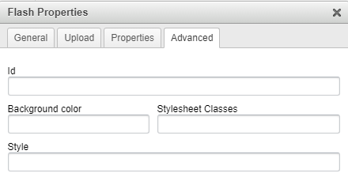 | - Id – a unique identifier for a Flash object element in the document (id attribute).  - Advisory Title – the text of the tooltip that is shown when the mouse cursor hovers over the Flash object (title attribute).  - Background color – the color that is visible beneath the transparent portions of the Flash object.  - Stylesheet Classes – the class of the Flash object element (class attribute). Note that a Flash object element might be assigned more than one class. If this is a case, separate class names with spaces.  - Style – CSS style definitions (style attribute). Note that each value must end with a semi-colon and individual properties should be separated with spaces.
Flash Object Preview
Please note that on inserting into the document, the Flash object will be displayed in the CKEditor editing area as a fake element.
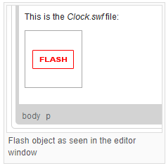 | If you want to check the final appearance of the object, press the toolbar button to use the Preview feature of Editor. The figure below shows the same Flash object in the preview mode.  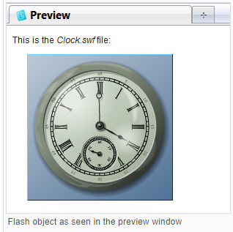
Table Icon : It is used to the insert create/insert a table in the page. To create a table in Editor, press the button on the toolbar. The Table Properties dialog window that will open lets you set configuration options that define table size, display properties, or other advanced properties.
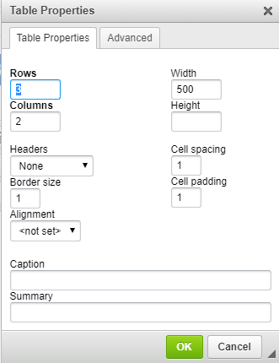  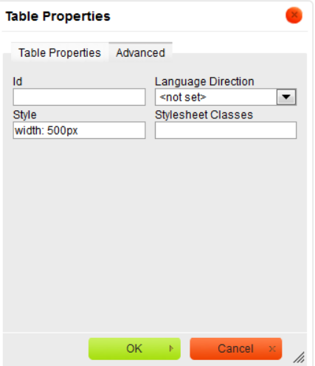 | Table Properties Tab  - Rows – the number of rows in the table (obligatory).  - Columns – the number of columns in the table (obligatory).  - Width – the width of the table in pixels or a percent value. Giving the width as a percent value lets you set the proportion of the editing area that the table will occupy.  - Height – the height of the table in pixels.  - Headers – the drop-down list that formats certain table cells as headers, which applies special formatting to them. You can apply header formatting to First Row, First Column or Both.  - Border size – the thickness of the table border in pixels.  - Alignment – the alignment of the table on the page. The following options are available: Left, Center, Right.  - Cell spacing – the space between individual cells as well as cells and table borders, in pixels.  - Cell padding – the space between the cell border and its contents, in pixels.  - Caption – the label of the table that is displayed on top of it.  - Summary – the summary of the table contents that is available for assistive devices like screen readers. It is a good practice to provide your tables with meaningful summary text in order to make it more accessible to users with disabilities.  Advanced Tab  The Advanced tab lets you configure additional image options such as assign it an ID, a class, a language direction, or CSS style properties. It is meant for advanced users with knowledge of HTML as well as CSS, and gives nearly endless possibilities as far as the presentation of the table is concerned.  - Id – a unique identifier for a table element in the document (id attribute).  - Language Direction – the direction of the text in the table: left to right (LTR) or right to left (RTL) (dir attribute).  - Stylesheet Classes – the class of the table element (class attribute). Note that a table element might be assigned more than one class. If this is a case, separate class names with spaces.  - Style – CSS style definitions (style attribute). Note that each value must end with a semi-colon and individual properties should be separated with spaces.

IFrame Icon : The <iframe> tag defines a rectangular region within the document in which the browser can display a separate independent HTML document from the third party it could be pages, forms, links, images including scrollbars and borders. It is used to reference the other document which is now part of the page using this icon.
- Place the cursor on the page where you want to insert an Iframe.
- Click on the Iframe icon, a window will pop-up as shown in the image below.
- Fill the required fields.
- Press ok to insert Iframe.

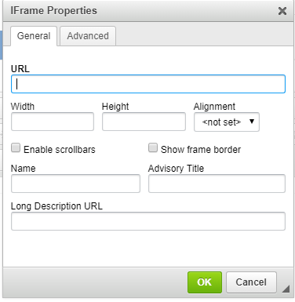  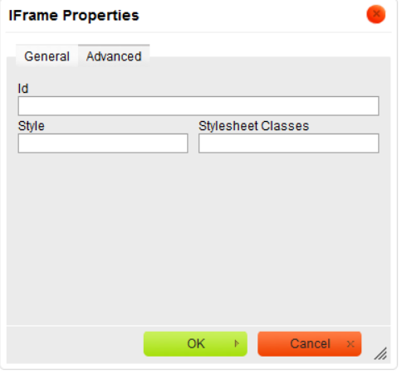 | - URL – the web address of the inline frame. The inline frame may be located on the same server as the web site you are currently in or on an external server.  External server: If you want to use an external address, use the full absolute path.  Example: http://example.com/iframe.html  Local server: If the inline frame is located on the same server, you can use a relative path that omits the domain name and starts with a slash.  Example:/pages/iframe.html  - Width – the width of the inline frame in pixels.  - Height – the height of the inline frame in pixels.  - Alignment – the alignment of the inline frame in the document. Available options are Left, Right, Top, Middle, and Bottom.  - Enable scrollbars – if this option is checked, when inserted content is larger than the space available in the iframe element, scrollbars will be displayed to enable the user to see the whole inline document.  - Show frame border – if this option is checked, the inline frame will be displayed with a border.  - Name – the name of the iframe element (name attribute).  - Advisory Title – the text of the tooltip that is shown when the mouse cursor hovers over the inline frame (title attribute).  - Long Description URL – the web address of an HTML page containing a longer description of the inline frame (longdesc attribute).

Advanced Tab
The Advanced tab lets you configure additional inline frame options such as assign it an ID, a class, or CSS style properties. It is meant for advanced users with knowledge of HTML as well as CSS, and gives nearly endless possibilities as far as the presentation of the iframe is concerned
- Id – a unique identifier for an inline frame element in the document (id attribute).
- Style – CSS style definitions (style attribute). Note that each value must end with a semi-colon and individual properties should be separated with spaces.
- Stylesheet Classes – the class of the inline frame element (class attribute). Note that an iframe element might be assigned more than one class. If this is a case, separate class names with spaces.

Document Tab
- The Documents menu is used for uploading word, pdf, and image files.
- Uploading document required fields are File Name, Choose File or Select File and shows list of the uploading document for that paged.
- Required fields are “Fill Name” and “Document.” File name must be unique.
- Select file drop down contains already uploaded files.

Once the Documents are uploaded they are saved in the Media library.
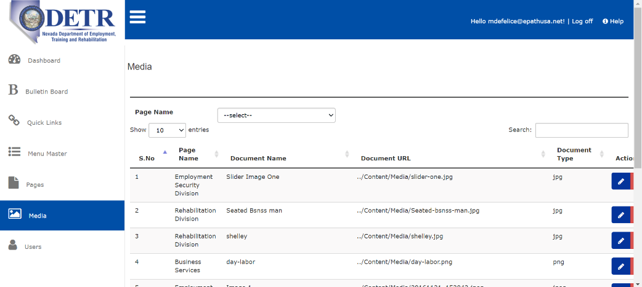

Add Document:
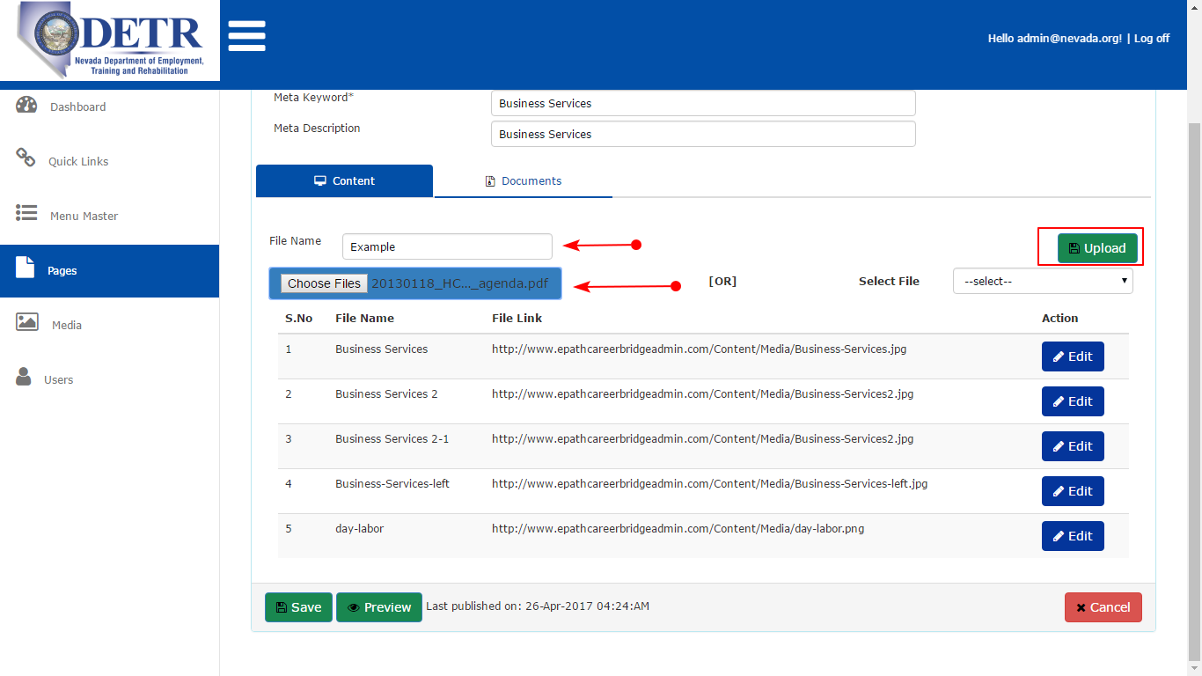

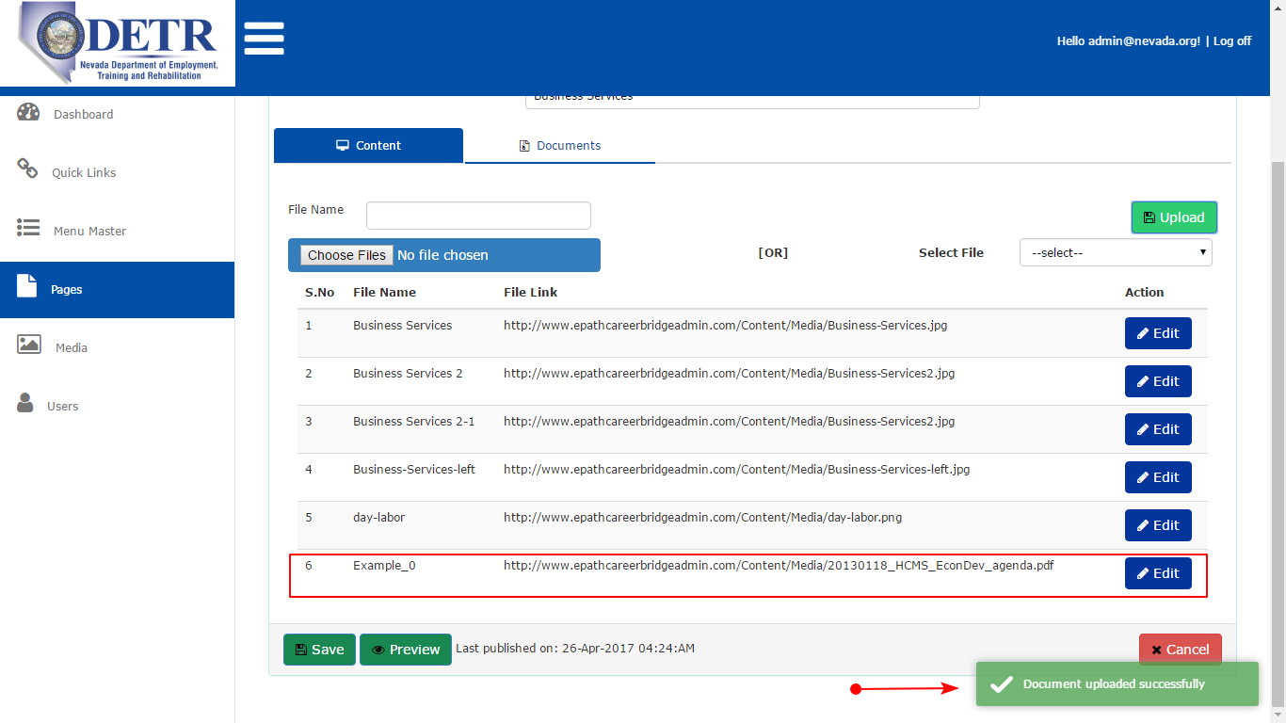

There is two ways to attach the Document in the page.
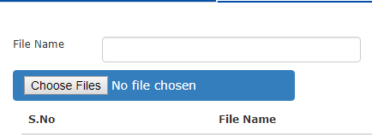 | 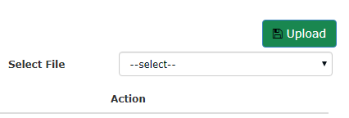

Option A | This option is used when a user wants to upload a file from the computer.  User can click on the choose files button, browser window will pop-up.  Choose the file and click open in the window as shown in the image in the left.  Use preview to see how the document will be visible in website.
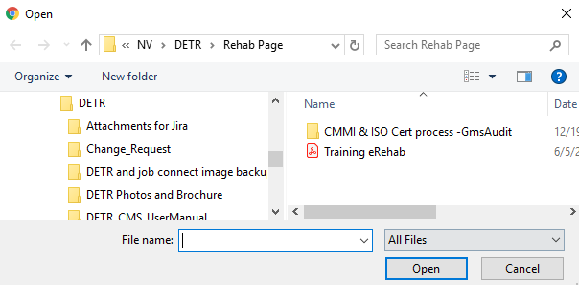
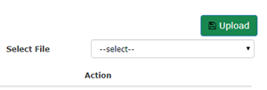  Option B | This option is used when a user wants to upload a file which is previously used in the website and is already stored in the media of website.  User must choose a file from the select file drop down as shown in the top left image.  Select the file and click upload. The file will get uploaded.  Use preview to see how the document will be visible in website.
Edit Document:
Click on edit button using document Id getting the document values.
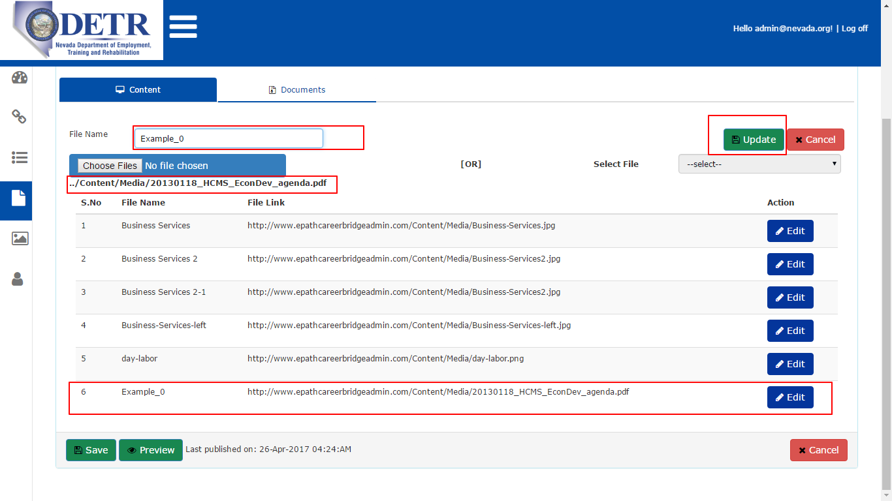
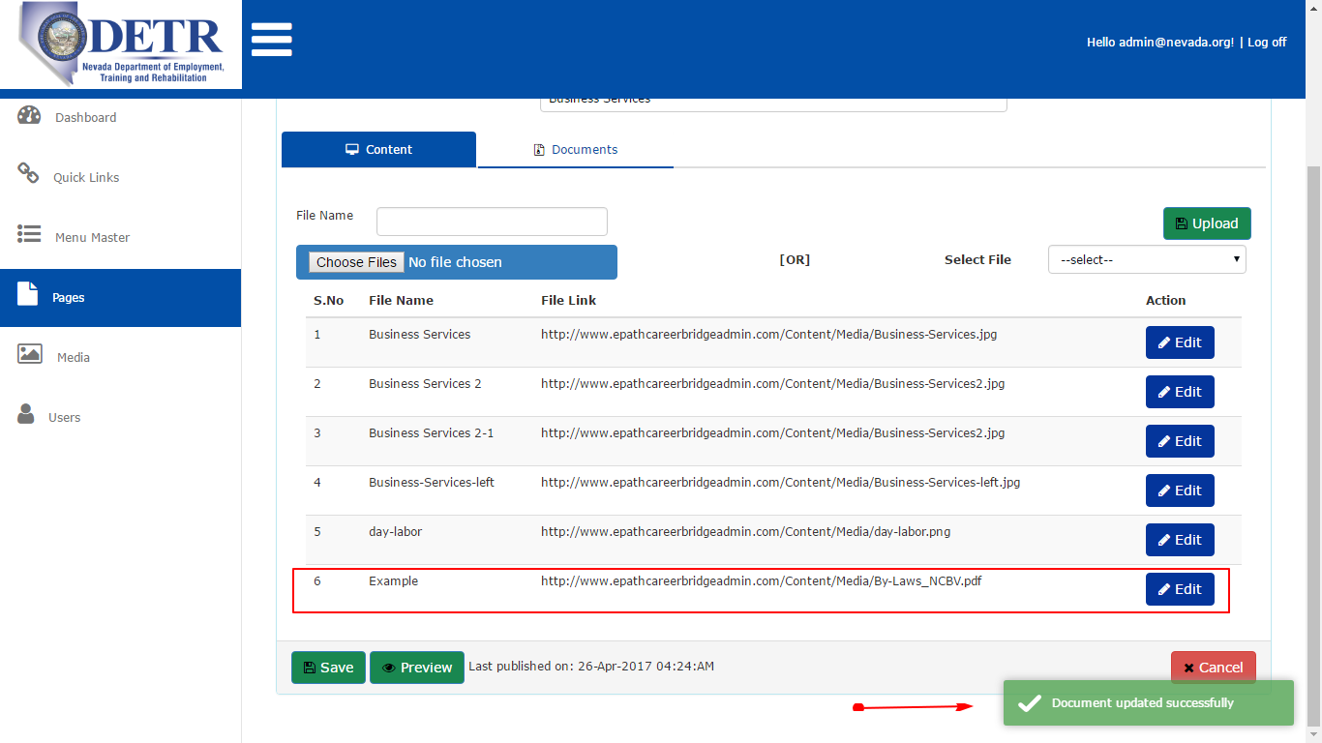

After the content of the page is created user can either save, preview, publish or cancel the page by the buttons in bottom of the page.

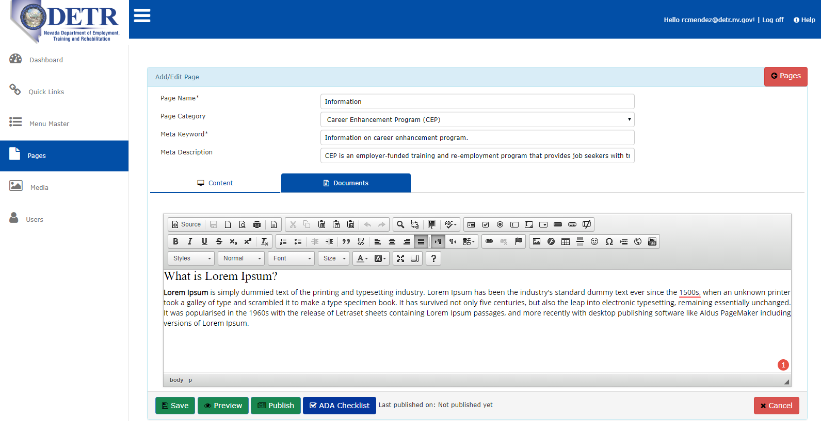

Save Button
- After entering all the required fields as shown in the image above, click Save. The page will be saved, and it will generate a new page ID, which will be referenced in URL’s.
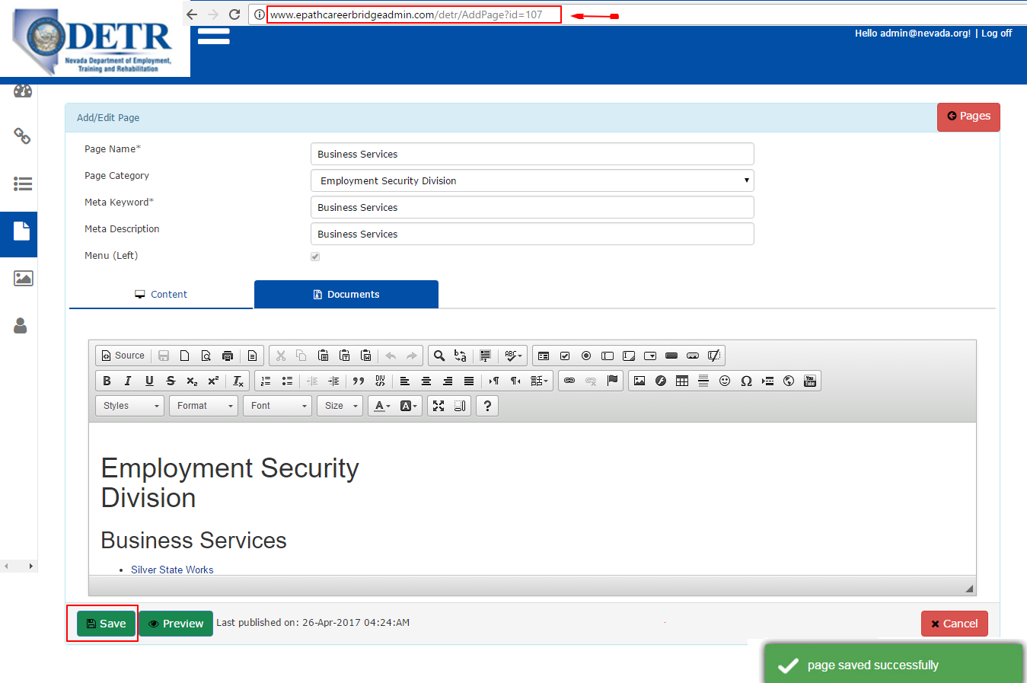
- There are 3 mandatory field which is required to fill before saving the page is Page Name, Page Category, Meta Keyword. If any of these three is not filled the page will prompt a message as shown in the image below.

Preview Button 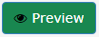

It is used to preview the edits in the web page. Click Preview any time while creating/editing a page to see how the page will be visible in the website, a new tab will open, and it will show the design of the web page. Please refer image below.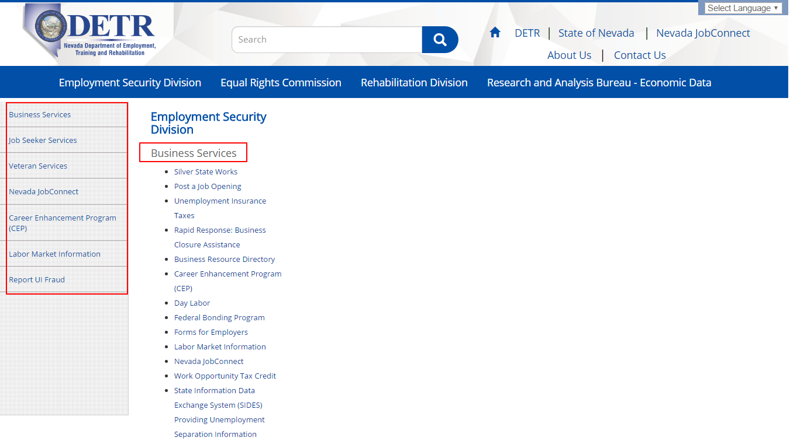

Note: To preview a page all three mandatory fields Page Name, Page Category, Meta Keyword must be filled

Publish Button 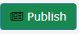:
It is used to publish the page on the website. Whenever a new page is created it is not visible in the website until it is published. Click on the publish button when the page is ready with the edits.
Once the button is clicked a message will pop up confirming page is published.

After approval from the publisher manager the page will be visible in the website. To publish the page, click on the button “Publish.” Until the page is published it will not be available for site navigation. The published date and timing is displayed at the bottom next to publish button.

To publish the page, click on the button “Publish.”
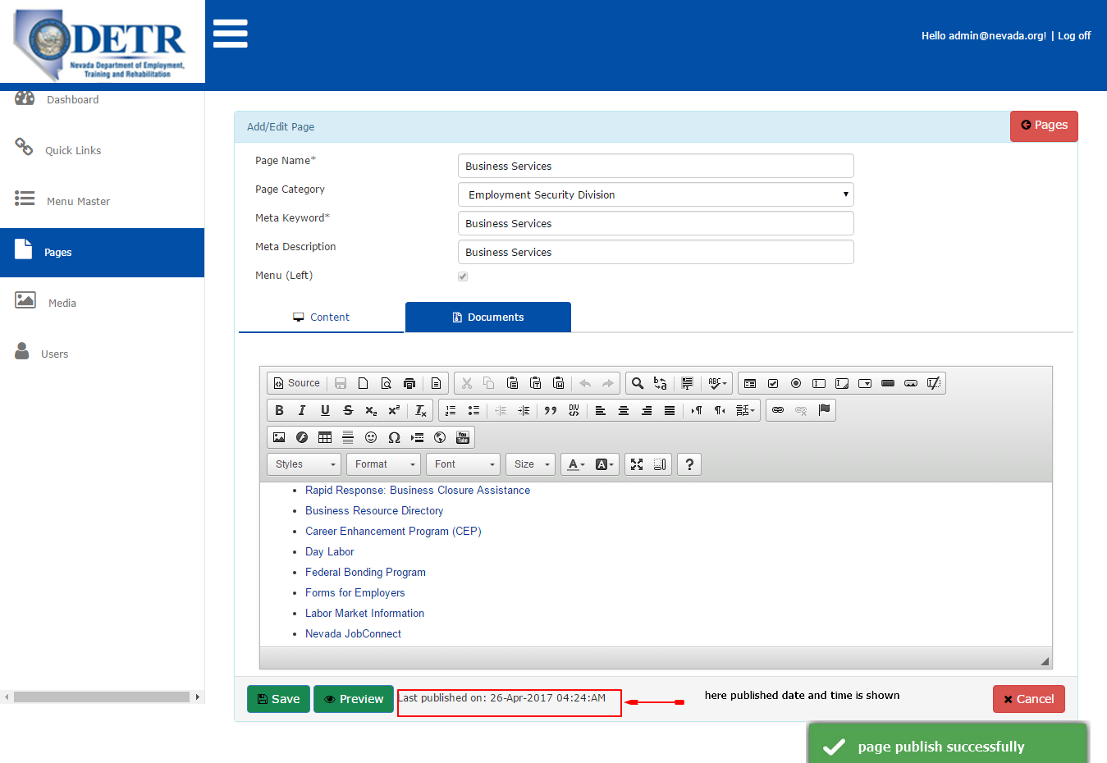

ADA Checklist 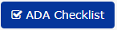
While creating a new page a user can always use this checklist to verify if the page is ADA compliant or not.
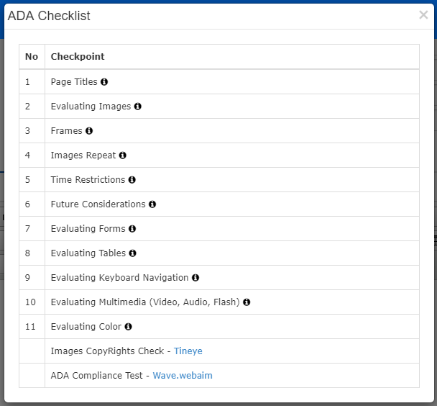

Cancel Button 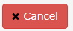
It is used to clear off the page and all the edits user had made. When the cancel button is clicked user is automatically moved out of the page editor window and is back to the “Pages” page.

Note: When cancel is clicked no changes are saved.

Edit/Update Published Page:
    - Click on edit page button using page ID all the fields’ content will show in Add/Edit window.
    - Here you can edit all page content, page categories, meta keyword and document.
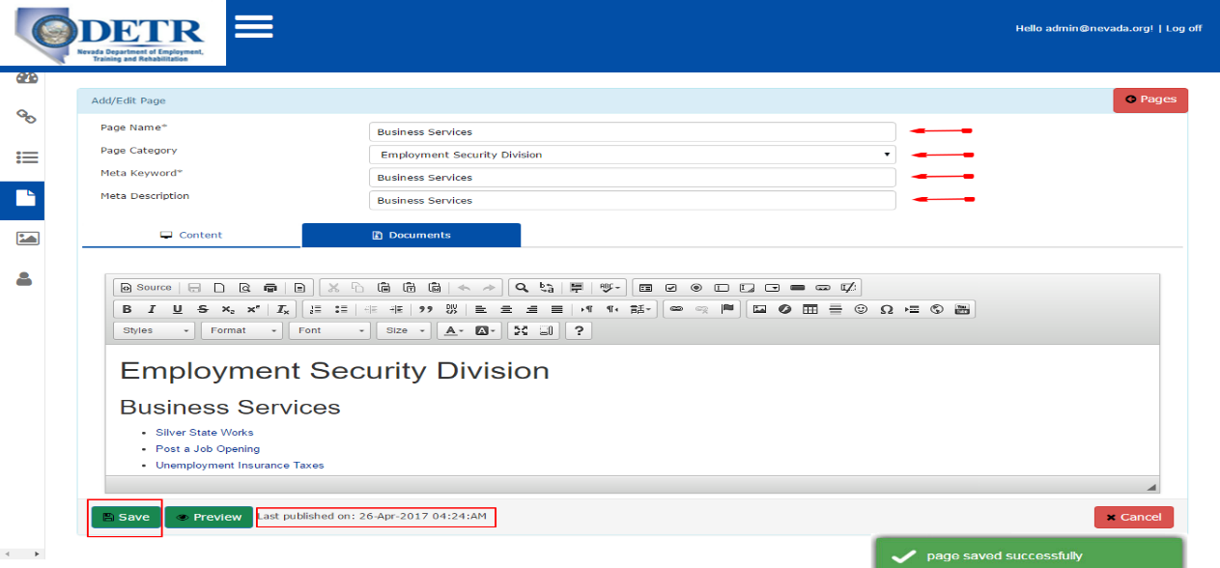

Media
- Media menu shows a consolidated list of the uploaded documents and images.
- View button click view the pdf file, word document and image files.
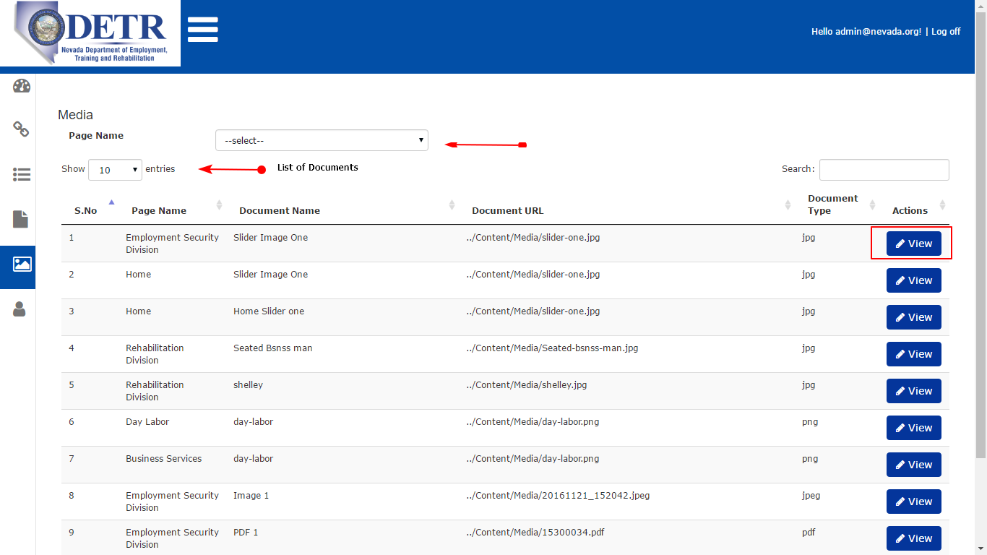

- Under media, each page name contains related document and/or image files are shown as shown on each page below.

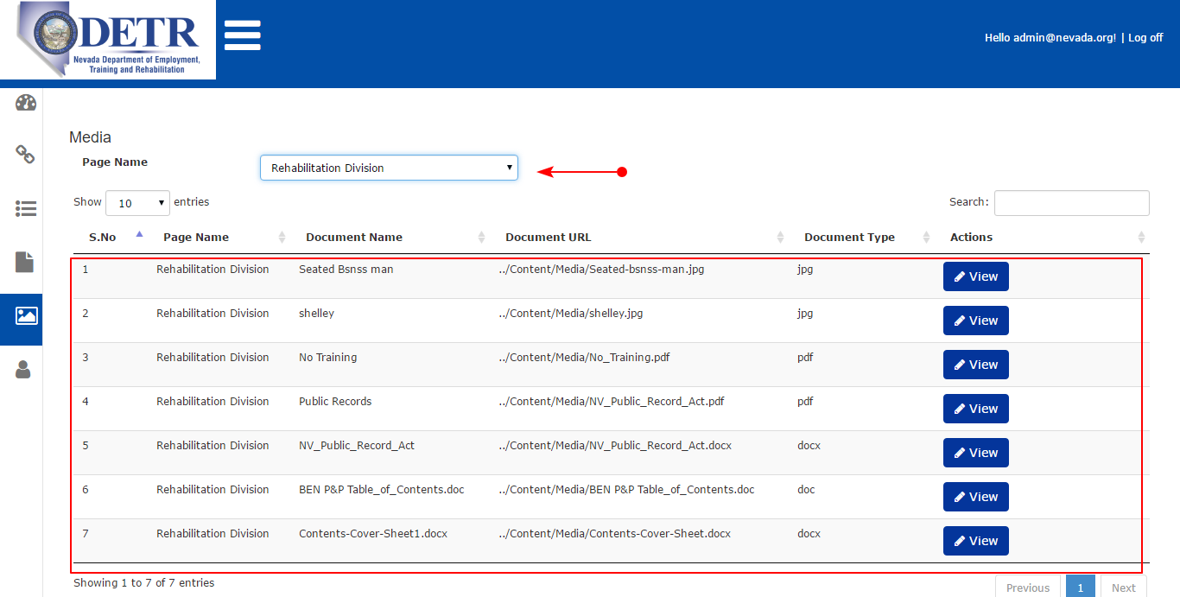
*******End of the Document *******

