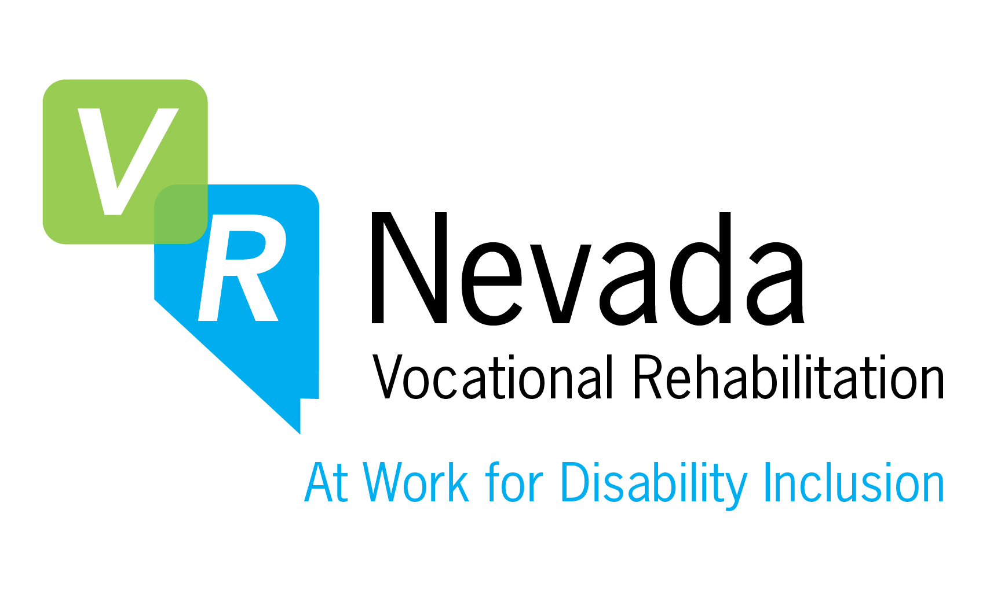
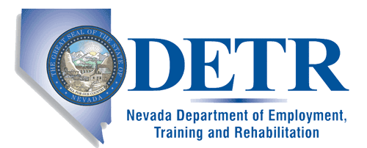
Brian Sandoval
Governor

Don Soderberg
Director

Shelley Hendren
Administrator

Rehabilitation
Division

Notice of Public Meeting
Nevada State Rehabilitation Council (N.S.R.C.)
Satisfaction Survey Sub-committee

Wednesday, April 19, 2017, 9:00 a.m.

Meeting Location:
Vocational Rehabilitation
3016 W. Charleston Blvd, Suite 200, Las Vegas, NV 89102

Teleconference Services: 1-888-557-8511
Access Code: 1883362

AGENDA

Call to Order, Introductions, and Verify Timely Posting of Agenda
Bill Heaivilin, Chair will call the meeting to order. Javier Fernandez, Council Liaison will verify the timely posting of the agenda, in accordance with Open Meeting Law. Ernest Hall will introduce Sub-committee members.

Public Comment
Mr. Heaivilin will call for public comment.
Members of the public will be invited to speak before; however, no action may be taken on a matter during public comment until the matter itself has been included on an agenda as an item for possible action. Please clearly state and spell your name. Public comment may be limited to three minutes, per person at the discretion of the chair.

- For Possible Action: Discuss Options for a potential new service contract for
the consumer satisfaction surveys to determine what the essential criteria will be included in the Request For Proposal (RFP) and submit recommendations for consideration by the council at the May 16, 2017 meeting.
Mr. Hall will lead the discussion.
.
4. Second Public Comment
Mr. Heaivilin will call for public comment.

Members of the public may now comment on any matter or topic, which is relevant to or within the authority or jurisdiction of the Council. You may comment now even if you commented earlier, however, please do not simply repeat the same comment you previously made. Please clearly state and spell your name. Public comment may be limited to three minutes, per person at the discretion of the chair.

5. Adjournment
Mr. Heaivilin will adjourn the meeting.

Sub-Committee Members

Bill Heaivilin (Sub-Committee Chair), Ernest Hall (NSRC Chair), Kim Cantiero (Bureau of Vocational Rehabilitation) and Kacy Curry (NSRC member).

Note: Items may be considered out of order. The public body may combine two or more agenda items for consideration. The public body may remove an item from the agenda or delay discussion relating to an item on the agenda at any time. The public body may place reasonable restrictions on the time, place, and manner of public comments but may not restrict comments based upon viewpoint. NRS 241.020(2)(d)(7). In accordance with the Attorney General’s Open Meeting Law Manual § 8.06, if a person willfully disrupts a meeting, to the extent that its orderly conduct is made impractical, the person may be removed from the meeting.
Note: We are pleased to make reasonable accommodations, including effective communication accommodations for members of the public who have disabilities that wish to attend the meeting. Please contact Laurel Kaneshiro (l-kaneshiro@nvdetr.org) 702-486-0372 or Beth Talcott (batalcott@nvdetr.org), Support Staff, in writing, at DETR, Rehabilitation Division, 751 Basque Way, Carson City, NV, 89706, or call 775-687-6860 (for individuals who are deaf or have hearing disabilities dial 711 for Relay Nevada), or send a fax to 775-684-4184 on or before 12 noon,
April 11, 2017.

Note: Individuals requesting supporting material as provided in NRS 241.020, Section 5 and all public records requests should be directed to the Public Records Official, Shelley Hendren (sghendren@nvdetr.org), Administrator, in writing, at DETR, Rehabilitation Division, 751 Basque Way, Carson City, NV, 89706, or Call 775-687-6860 or Fax to 775-684-4184 (for individuals who are deaf or have hearing disabilities dial 711 for Relay Nevada).
Notice of this meeting was posted on or before 9 a.m. on the third day prior to the meeting at:
- DETR, Rehabilitation Division, 751 Basque Way, Carson City, NV, 89706;
- DETR Administrative Office, 2800 E. St. Louis Ave., Las Vegas, NV 89104
- DETR Bureau of Vocational Rehabilitation and Bureau of Services to the Blind and Visually Impaired, 3016 W. Charleston Blvd., Ste. 200, Las Vegas, NV 89102
- Easter Seals Southern Nevada, 6200 W. Oakey Blvd., Las Vegas, NV 89107
- NV PEP, 7211 W. Charleston Blvd., Las Vegas, NV 89117
- Nevada Disability Advocacy & Law Center, 2820 W. Charleston Blvd, #11, Las Vegas, NV 89102;
- Office of Aging & Disability Services, 1860 E. Sahara Ave, Las Vegas, NV 89104
- Southern Nevada Center for Independent Living, 6039 Eldora Ave., Suite F, Las Vegas, NV 89146
- JobConnect – Henderson, 4500 E. Sunset Rd, Ste 40, Henderson, NV 89014
- JobConnect – Las Vegas, 3405 S. Maryland Pkwy, Las Vegas, NV 89169
- JobConnect – North Las Vegas, 2827 Las Vegas, Blvd, North, North Las Vegas, NV 89030

Notice of this meeting was posted on or before 9 a.m. on the third day prior to the meeting on
the Internet at: DETR’s Public Meetings website –
www.nvdetr.org, http://nvdetr.org/publicmeetings.htm; and Nevada’s Public Notice website at
https://notice.nv.gov/, as required by NRS 232.2175.

